Chapter 5. Priority Populations

Introduction

Data from numerous sources show that some racial, ethnic, socioeconomic, and geographic groups suffer disproportionately from preventable or treatable chronic conditions. Assessing disparities in health care provided to U.S. residents at greatest risk of debilitating and costly illnesses enables policymakers to pinpoint areas where interventions can make the greatest overall difference in reducing national health care disparities.

The consequences of health care disparities for these groups reverberate throughout the society by lowering national health indicators and contributing to escalating health care costs. Moreover, characteristics and conditions of people within these populations are likely to overlap in ways that exacerbate disparities.

One goal of this report is to increase understanding of the independent effects of demographic characteristics on health care. While substantial work has been done on the impact of ethnicity and race on health care disparities, quality, and outcomes, much less is known about the independent consequences of varying levels of income and education, as well as geographic location. In this chapter, the NHDR analyzes the role of socioeconomic position and geographic location—separate from racial and ethnic factors—on health care disparities within and across priority populations (e.g., comparing low-income women with high-income women). Disentangling these complex causal factors provides the fact-based foundation that policymakers need to devise and evaluate health care policies and programs. This chapter provides additional perspective on which factors are most important to implement effective programs to eliminate inappropriate disparities in care.

Which Groups Are Included in the Report?

The statutory mandate for this report refers to “priority populations,” a term that is defined in AHRQ’s authorizing statute (section 901 (c) of the Public Health Service Act) as encompassing both specific population groups as well as geographically defined groups. In accordance with these guidelines, the NHDR includes data and analysis on the following:

- Low-income groups
- Racial and ethnic minority groups
- Women
- Children
- Elderly
- Individuals with special health care needs, specifically children with special needs, the disabled, people in need of long-term care, and people requiring end-of-life care.

Rural populations, mentioned elsewhere in the authorizing legislation, are also included. Although other demographic groups may also suffer from health care disparities, they are not considered in this report. For each group, selected findings are highlighted for quality of and access to care.

The NHDR uses categories are compliant with OMB standards for reporting Federal statistics. These standards consider race and Hispanic origin to be two separate and distinct concepts. Racial categories are: white, black, Asian, Native Hawaiian or Other Pacific Islander (NHOPI), American Indian or Alaska Native (AIAN), and more than one race. Because Hispanics can be of any race, all racial categories can include persons of Hispanic and non-Hispanic origin. Ethnic categories are: Hispanic or Latino, non-Hispanic white (i.e., whites who do not list their ethnicity as Hispanic) and non-Hispanic black (i.e., blacks who do not list their ethnicity as Hispanic).

A Word About Data

Both the reauthorization legislation and the IOM guidance for the NHDR direct AHRQ to assess the usefulness of the data available for analysis of health care quality (including health care disparities). The forthcoming analyses of the priority populations clarify both the limitations and potentialities of current data sets.

Priority populations are already subsets of the general population. Subdivision into smaller groups for analysis by different variables, factors, or conditions often results in sample sizes that are often too small to yield statistically valid results. As noted in earlier chapters, the omission of racial, ethnic, and socioeconomic data from information gathered in health care settings limits our ability to make comparisons.

For these reasons, this chapter does not provide a comprehensive assessment of health care disparities in priority populations. Instead, it should be seen as a starting point, identifying some problem areas and indicating gaps in current data and understanding.

Women
Introduction

“We are in the midst of a revolution in women’s health; a revolution that has brought new attitudes, awareness and an appreciation that women have some fundamentally different health needs that need to be addressed in their own right. ”
-HHS Secretary Tommy G. Thompson

Over the past decade, women’s health has become a research and policy priority. By one rough measure, a Journal of the American Medical Association editorial notes that the number of indexed clinical trials under “women and health” grew from 66 in 1992 to 276 in 1998; and in 2000, the journal received one of the highest responses ever for a call for papers on the topic. While life expectancy for women is approximately 6 years greater than that for men, they suffer higher morbidity rates than their male counterparts. An oft-cited maxim is that “men die quicker, but women live sicker.”

Women also comprise the majority of persons needing long-term care; three of four nursing home residents and two of three home care consumers are female. Additionally, women are at greater risk for Alzheimer’s disease than are men and are twice as likely as men to be affected by major depression.

The number of women in the United States who do not have health insurance has grown three times faster than the number of men without health insurance over a 5-year period. Uninsured women are nearly 20% more likely to have difficulty obtaining health care services than uninsured men. The majority (roughly 3 out of 5) of low-income uninsured patients are low-income mothers.

Health care is particularly important to women during pregnancy, a critical period when care (or lack of it) can have far-reaching consequences for both mother and child. While approximately 17% of mothers-to-be do not start prenatal care in the first trimester, provision of prenatal care has increased for all women over the last decade. Black women, however, are more likely to die from complications of childbirth than white women. These findings suggest that, while prenatal care is essential, it is likely that as yet unresolved scientific issues may contribute to excess mortality among pregnant black women. In addition, these findings underscore the additional value of examining care provided to different subgroups: identification and clarification of critical scientific issues.

Quality of Care

This section evaluates quality of health care for women in terms of effectiveness, safety, timeliness, and patient centeredness. It also identifies which areas health care quality varies among female subpopulations.

Effectiveness of Care

Health care is “effective” when appropriate, proven medical services and treatments are provided to all who could benefit, and not provided to those unlikely to benefit. In general, disparities observed in the general population were echoed in the female population. For example, few differences were observed in measures relating to chronic renal disease, heart disease, and frailty in old age.

The following discussion of health care effectiveness for women provides an overview of treatment patterns that can help identify data needs and suggest additional areas for future research.

Cancer screening

Since the passage of the 2000 Breast and Cervical Cancer Prevention and Treatment Act, 40 States have begun to cover breast and cervical cancer treatment through Medicaid for uninsured women under age 65.

In general, minority women and women of lower socioeconomic position are less likely to receive many cancer screening services. One exception may be cervical cancer screening among black women. Specifically, blacks (84%) are more likely than whites (82%) or Asians (66%) to report receipt of Pap smears in the past 3 years. Hispanic women (77%) are less likely than non-Hispanic whites (83%), and poor (73%), near poor (75%), and middle income (81%) women are less likely than high income women (88%) to report recent Pap smears. Similarly, high school dropouts (74%) and high school graduates (81%) are less likely than women with any college education (86%) to report Pap smears in the past 3 years. As in the general population, black, Hispanic, and women of lower socioeconomic position are less likely to receive screening for colorectal cancer (see Chapter 3) (NHIS, 2000).

Diabetes

Women appear to fare better than men in diabetes care. While rates of retinal screening represent substantial improvements overall in the past few years, within the general population, the poor report annual retinal eye examinations (63%) less frequently than those with high incomes (74%). Among women, the differences are not significant (see Chapter 3) (MEPS, 2000). Similarly, although black and Hispanic diabetics in the general population are less likely to receive influenza vaccination, these differences are greatly reduced among women.

HIV/AIDS

In general, disparities related to HIV/AIDS are larger among women than among men or the general population. Overall, the rate of new AIDS cases is higher non-Hispanic blacks, Hispanics, and AI/ANs compared with non-Hispanic whites. These racial and ethnic disparities are also observed among women, but relative effect sizes tend to be larger. Among women age 13 and over, new AIDS cases are reported at a higher rate among non-Hispanic blacks (48 per 100,000 population), Hispanics (12 per 100,000), and AI/ANs (7 per 100,000), compared with non-Hispanic whites (2 per 100,000) (HIV/AIDS Surveillance System, 2000).

HIV/AIDS death rates in the general population are higher among blacks and patients with lower education. Among women, HIV/AIDS death rates are also higher among blacks (13 per 100,000 population) compared with whites (1 per 100,000) and among high school dropouts (13 per 100,000) and high school graduates (7 per 100,000) compared with persons with any college education (1 per 100,000), but again relative effect sizes are larger.

Maternity care

Black (74%), NHOPI (77%), and AI/AN (69%) women are less likely to receive prenatal care during the first trimester than white women (85%). Similarly, Hispanics (75%) are less likely than non-Hispanic whites (89%), while high school dropouts (70%) and high school graduates (83%) are less likely than women any college education (92%) to initiate early prenatal care (see Chapter 3). In addition, minority and less educated mothers are more likely to die from obstetrical complications (NVSS, 2000).

Mental health

Suicide rates are higher for female high school dropouts (6.5 per 100,000 population) and female high school graduates (7.3 per 100,000) compared with females with any college education (4.8 per 100,000) (NVSS-M, 2000).

Respiratory diseases

The percent of male nursing home residents who ever received pneumococcal pneumonia vaccination is similar between blacks (30%) and whites (32%). However, among women, this measure is significantly lower among blacks (21%) compared with whites (36%) (NNHS, 1999). Sample sizes only allow for black-white comparisons.

Patient Safety

The prime directive of medical care is to do no harm, but the Institute of Medicine report, To Err is Human, estimated that 44,000 to 98,000 Americans die each year as a result of medical errors, making it the eighth leading cause of death. This report also estimated costs attributable to medical errors totaling $29 billion annually. Two aspects of the patient safety among women are included in this section: inpatient safety and medication safety.

Inpatient safety

Minorities and residents of lower income ZIP Codes tend to have lower rates of obstetric trauma. For example, rates of serious lacerations or other obstetric trauma during instrument-assisted deliveries are lower among non-Hispanic blacks (193 per 1000 instrument-assisted deliveries) and Hispanics (200 per 1000) compared with non-Hispanic whites (235 per 1000). The rates are also lower among women who live in poor areas (183 per 1000 instrument-assisted deliveries) and near-poor areas (207 per 1000), compared with women who live in high-income areas (238 per 1000) (see Chapter 3) (HCUP SID 16-State database, 2000). Differential rates of obstetric trauma may be due to differential rates of episiotomy.

Among other inpatient safety indicators differences among women typically parallel variation in the general population. However, one exception is noted: among all hospitalized patients and among hospitalized men, rates of postoperative abdominal wound dehiscence are not significantly different between non-Hispanic blacks and non-Hispanic whites. Among women, this measure is higher among non-Hispanic blacks (1.3 per 1,000 abdominopelvic surgery discharges) compared with non-Hispanic whites (0.6 per 1,000).

Medication safety

In the general population, as well as among women, the percentage of patients whose provider does not usually ask about medications and treatments from other doctors is higher among blacks compared with whites and among Hispanics compared with non-Hispanic whites (see Chapter 4). In addition, this measure is also higher among API women (MEPS, 1999).

Timeliness

Health care cannot prevent death and disability if it is delivered too late, and delays can lead to complications that ultimately increase health care costs. In general, trends of disparities in measures of timeliness are similar between women and the population as a whole.

Patient Centeredness

This section considers the health care system’s obligation to provide care that is respectful of and responsive to individual patient preferences, needs, and values, and to ensure that patient values guide all clinical decisions. Health care recommendations must be personalized to ensure that they are concordant with patient values, properly understood, and followed. Measures of patient centeredness overlap with the concepts of patient-provider communication and patient-provider relationship discussed under Access to Health Care, below. In general, disparities in measures of patient centeredness are similar between women and men.

Access to Care

This section focuses on factors that relate to initial contact with the health care system that aid or hinder entry into the system. These measures cover health insurance coverage, usual source of care and unmet need.

Health insurance

Racial, ethnic, and socioeconomic disparities in health insurance coverage among women are similar to differences within the general population. Among women, blacks (28%) are more likely than whites (23%), and Hispanics (45%) more likely than non-Hispanic whites (21%) to spend any time during the year being uninsured. As with the general population, the probability of being uninsured follows an income gradient, such that poor (43%), near poor (40%), and middle income (23%) women are more likely to have spent time being uninsured than high income (11%) women. Female high school dropouts are considerably more likely (43%) to spend time being uninsured than those who attended at least some college (17%). Again mirroring general population trends, AI/AN (34%) and black women (30%) are considerably more likely than white women (13%) to receive public coverage, and Hispanic women (27%) are nearly twice as likely as non-Hispanic white women (14%) to have spent time being publicly insured. Finally, women with fewer than 12 years of education are more than 7 times as likely to have public insurance at any point during the year as those with more than 12 years (29% vs. 4%, respectively) (MEPS, 1999).

Usual source of care

In the overall population, racial, ethnic, and SES disparities exist in access to a usual source of care. Similarly, female Hispanics (82%, vs. 92% of non-Hispanic whites) and poor (84%), near poor (85%), and middle income women (92%, vs. 95% of high income women) are less likely to have a usual source of care (NHIS, 2000).

Money is often a constraint. Women are more likely than men to cite financial reasons for having no usual source of care, and priority populations represent a disproportionate amount of these respondents. Specifically, Hispanic women (23%, vs. 14% of non-Hispanic white women), poor women and near poor women (22% and 23%, respectively, vs. 8% of high income women), and female high school dropouts (23%, vs. 11% of women with at least some college) report that financial limitations prevent them from having a usual source of care (MEPS, 1999).

Women and men are equally likely to rely upon a hospital, emergency room, or clinic as a usual source of care. Within the female population, however, differences exist: AI/ANs (47%) and blacks (26%) are more likely to depend upon these institutional sources of care than are whites (15%). Similarly, Hispanic women (25%) are more likely than non-Hispanic white women (14%), and poor, near poor, and middle income women (32%, 24%, and 16%, respectively) are more likely than high income women (11%) to depend upon these delivery sites for their primary care (NHIS, 2000).

Patient perceptions of inadequate access and need

Female respondents who are concerned about their ability to receive medical care if they should need it are frequently members of priority populations. For example, Hispanics (38%) are more likely than non-Hispanic whites (26%), poor (34%), near poor (33%), and middle income women (26%) are more likely than those with high income (20%), and women who did not finish high school (33%) are more likely than those who completed at least some college (24%) to be dissatisfied that they can obtain health care if they should need it (MEPS, 1999).

This dissatisfaction and concern is often borne out by experience. The following groups of women are less likely to “always obtain care for an illness or injury as soon as desired”: APIs (36%, vs. 54% of whites), Hispanics (39% vs. 55% of non-Hispanic whites), and the poor (47%, vs. 55% of those with high incomes) (MEPS, 2000). Similarly, the following groups of women are less likely to always be able to schedule appointments for routine care as soon as they wanted: APIs (29%, vs. 42% of whites), Hispanics (34%, vs. 43% of non-Hispanic whites), 48% of the poor (compared with 41% of those with high incomes), and 44% of those with less than a high school education (compared with 40% of college attendees).

Getting care

Access to off-hour care is restricted for many women. For example, poor women (43%, vs. 52% of high income women) and high school dropouts (39%, vs. 45% of women who attended college) are less likely to have the option of scheduling off-peak appointments. Interestingly, API women are actually more likely than white women (55% vs. 49%) to frequent clinicians that offer flexibility in scheduling off-peak appointments. Yet despite their ability to schedule appointments, API women tend to be less satisfied with the professional staff at their usual source of care’s office (36%) than white women (25%) (MEPS, 1999).

Another important measure of getting care is the ability to see specialists. Hispanic women (69%, vs. 83% of non-Hispanic white women) and poor women (70%, vs. 84% of high income women) are less likely to report that they had no problems obtaining referrals to specialists (MEPS, 2000).

Waiting times

Once at the health care delivery site, certain groups of women are more likely to have to wait over 30 minutes before being seen by a clinician. Women who are black (20%, vs. 15% of whites), Hispanic (25%, vs. 14% of non-Hispanic whites), poor (25%, vs. 12% of those with high incomes), and who did not complete high school (23%, vs. 12% of college attendees) are more likely to experience long waits to see their health care provider (MEPS, 1999).

Even more pressing, black women are more likely both to wait over 1 hour for emergent/urgent care (15%, vs. 12% of white women) and for semi-urgent/non-urgent care (31%, vs. 24% of white women) in hospital emergency departments (NHAMCS-ED, 1999-2000).

Patient-provider communication

Among women, some groups are more likely than others to report having poor communication with their health care provider at their last visit—specifically: women who are black (24%) and Asian (28%, compared with 18% of whites), Hispanic (29%, compared with 17% of non-Hispanic whites), poor (29%, compared with 15% of high income women), and have less than a high school education (30%, compared with 18% of college attendees) report problematic communication at their last doctor’s visit (Commonwealth Fund Health Care Quality Survey, 2001).

Patient-provider relationship

Men and women have similar rates of satisfaction with care and similar ratings of their health care. However, racial, ethnic, and socioeconomic disparities among women exist. For example, APIs (31%, vs. 20% of whites) and Hispanics (24%, vs. 19% of non-Hispanic whites) are more likely to report dissatisfaction with the quality of care their provider offers (MEPS, 1999).

These same female subpopulations also report low levels of satisfaction with their overall health care. Specifically, among women, APIs (31%) and blacks (20%, vs. 16% of whites), Hispanics (19%, vs. 15% of non-Hispanic whites), the poor (25%, vs. 15% of those with high-incomes), and high school dropouts (21%, compared with 15% of women who attended college) reported lower satisfaction with care (MEPS, 2000).

Cultural competency

Cultural values and ideas about what constitutes good health can vary between demographic groups. “Cultural competency” implies an awareness of health beliefs and behaviors, disease prevention and incidence, and treatment outcomes for different populations. It is, however, important to note that we have much to learn about how to operationalize cultural competency. Echoing findings in the general population, women who are black (17%), Asian (13%, compared with 2% of whites), Hispanic (16%, vs. 1% of non-Hispanic whites), and poor (11%, vs. 3% of those with high incomes) are more likely to believe that they would have received better care if they were a different race or ethnicity. Furthermore, high school dropouts (33%) are less likely than women who attended college (41%) to report that their doctors understand their background and values (Commonwealth Fund Health Care Quality Survey, 2001).

Health information

Women are more likely than men to understand and use health information. For example, women report that prescription medication instructions are difficult to understand less often (18%) than do men (23%). Consistent with findings in the general population, women who are Asian (39%, compared with 17% of white women) and Hispanic (35%, vs. 15% of non-Hispanic white women) are more likely to find prescription bottle information difficult to understand (Commonwealth Fund Health Care Quality Survey, 2001).

Chronic care

Due to sample size constraints, both data sources used for chronic care measures only provide black-white comparisons. In general, disparities in chronic care do not differ between women and men (NHHCS, 2000 and NNHS, 1999).

Mental health care and substance abuse treatment

Mirroring trends in the general population, minorities tend to be less likely to receive mental health treatment or counseling, especially outpatient treatment. For example, black women (9%) and Hispanics (7%) are less likely than whites (15%) and non-Hispanic whites (16%) to have received mental health treatment or counseling in the past year (NHSDA, 2001). These data are particularly important given the fact that depression is the second leading cause of hospitalizations for women of reproductive age (HCUP Chartbook). Data on substance abuse treatment do not allow assessment of disparities among women.

HIV care

Frequency of inpatient hospitalization of female HIV patients mirrors trends seen in the general HIV population: non-Hispanic black women (20%) and Hispanic women (19%) more frequently receive inpatient HIV care than non-Hispanic white women (13%) (HIV Research Network, 2000).

Avoidable admissions

Avoidable admissions (also called “admissions of ambulatory care sensitive conditions”) are hospitalizations for health conditions that, in the presence of comprehensive primary care, rarely require hospitalization. High rates of avoidable admissions suggest impaired access to or quality of ambulatory care.

Similar to the general population, non-Hispanic black women typically have higher rates of avoidable admissions, while API women typically have lower rates. One exception may be in admissions for chronic obstructive pulmonary disease, where rates are higher among non-Hispanic black men (345 per 100,000 population 18 and over) compared with non-Hispanic white men (264 per 100,000). In contrast, rates are lower among non-Hispanic black women (231 per 100,000 population 18 and over) compared with non-Hispanic white women (269 per 100,000).

Children

Introduction

The health and well-being of children has long been a research and policy priority in the United States and worldwide., Children are recognized as deserving of special attention for at least three reasons: childhood is a unique developmental stage of life, child health must provide continuity with adult health, and the child health care system is distinctive.

Childhood is a unique period of life. At least four distinguishing characteristics (“the 4 D’s”) have important implications for health care for children:

- Developmental change—children develop at a rapid rate and their health depends in large measure on the success of their cognitive, emotional, and physical growth and development
- Dependency—on parents and other adults for financing, accessing and receiving health care (some exceptions for some adolescents)
- Differential epidemiology—children experience a unique pattern of health, illness, and disability
- Demographic patterns—the high rate of children living in poverty, the disproportionate numbers of children who are racial and ethnic minorities, and the high rates of single-parent families shape both children’s health and health care.Error: Reference source not found

Reflecting these differences, a unique set of financing and organizational arrangements have evolved for children in the U.S. health care system. Part of society’s obligation to children has been expressed in the special attention paid to children for public payment of their health care. For example, poor children are a mandatory population for the Medicaid program, and adolescents were added gradually over time as optional populations. In 1997, the State Children’s Health Insurance Program (SCHIP) was passed to provide coverage to certain low-income children who were not eligible for Medicaid and otherwise not insured. The Maternal and Child Health Block Grant program and other public programs provide direct financing of some services for children. Families of some disabled children also can receive cash benefits from Social Security to help pay health care and related costs that otherwise remain uncovered.

This chapter summarizes NHDR findings on children in general. It also focuses on disparities within the child population for racial and ethnic minority children and children of different income levels. Disparities affecting children with special health care needs are addressed in the chapter on individuals with special health care needs. Because many child-specific health care needs and services are not explicitly addressed and sample size limitations exist, these findings should not be interpreted as a comprehensive assessment of disparities in health care among children.

Quality of Care

Effectiveness of Care

Not all measures of effectiveness included in the quality of care measure set are applicable to children; some are applicable because children suffer from the disorders but have not been applied to children or to racial and ethnic minority children or children of different socioeconomic statuses. One reason that more quality of care measures have not been developed for children is the limited evidence on whether or not specific child health care interventions are effective. Eight aspects of the effectiveness of child health care are included in this section:

- HIV/AIDS
- Prenatal care
- Low birthweight
- Childhood and adolescent immunization
- Childhood dental care
- Treatment of pediatric gastroenteritis
- Mental health
- Respiratory diseases

HIV/AIDS

Among adolescents ages13 to 17, new AIDS cases are being reported at a higher rate among non-Hispanic black (3.5 per 100,000 population) and Hispanic (1.0 per 100,000) adolescents compared with non-Hispanic white adolescents (0.2 per 100,000) (CDC HIV/AIDS Surveillance System, 2000).

Among children, HIV infection death rates are higher among black children (0.5 per 100,000) compared with white children (0.1 per 100,000) (NVSS-M, 2000).

Prenatal care

Among adolescent mothers under 15, prenatal care is less often initiated by blacks (41%) and AI/ANs (43%) compared with whites (51%) but is similar between Hispanics (49%) and non-Hispanic whites (53%) (NVSS, 2000).

Childhood and adolescent immunization

Blacks are less likely to receive childhood immunizations compared with whites, and lower income children are less likely to receive immunizations compared with more affluent children. For example, receipt of all recommended vaccinations is achieved by fewer black children (68%) than white children (75%) and by fewer children in poor (68%), near poor (71%), and middle income (75%) families, compared with children in high income families (79%) (see Chapter 3). In contrast, receipt of the varicella vaccine is achieved more often by Asian (82%) and Hispanic (80%) children than by white (76%) and non-Hispanic white (75%) children, respectively (NIS, 2001). There is no evidence of disparity for adolescent immunizations (NHIS).

Childhood dental care

Black children receive fewer dental visits (32%) than white children (50%), and Hispanic children receive fewer (33%) than non-Hispanic white children (54%). Additionally, children who are poor (30%), near poor (36%), and middle income (50%) are less likely than high income children (63%) to see a dentist. Finally, uninsured children (24%) have fewer dental visits than privately insured children (54%) (MEPS, 1999).

Treatment of pediatric gastroenteritis

Pediatric gastroenteritis, one of the most common reasons for pediatric hospitalizations, can be treated on an outpatient basis, and proper outpatient treatment can reduce admissions for gastroenteritis among children. Rates of hospitalization for pediatric gastroenteritis are higher among Hispanic children (133 per 100,000 population) and lower among API children (47 per 100,000) compared with white children (115 per 100,000). Because information on patient income and education is not available, median income of patient’s ZIP Code is used as a crude proxy of socioeconomic position. Hospitalization rates are higher among children who live in poor areas (172 per 100,000 population), near-poor areas (157 per 100,000), and medium-income areas (124 per 100,000) compared with children who live in high-income areas
(86 per 100,000) (HCUP SID, 2000).

Mental health and substance abuse

Among children, rates of suicide are lower among black (1.0 per 100,000 population) and API (0.8 per 100,000) children than white children (1.7 per 100,000) and among Hispanic children (0.9 per 100,000 population) than non-Hispanic white children (1.8 per 100,000). However, AI/AN children have the highest rates of suicide of all groups (3.8 per 100,000 population) (NVSS-M, 2000).

Among children ages 12 to 17, substance abuse treatment is reported less frequently by non-Hispanic blacks (0.8%) compared with non-Hispanic white (1.6%) (National Household Survey on Drug Abuse, 2001)

Respiratory diseases

Data on treatment of upper respiratory infection come from NAMCS/NHAMCS in 1999-2000. Evidence of significant racial disparity is not present. Hospitalization rates among black children (60 per 10,000 population) and adults (21 per 10,000) tend to be higher than rates among white children (17 per 10,000) and adults (8 per 10,000) (NHDS, 2000).

Patient Safety

Two aspects of the child patient safety are included in this section: inpatient safety and medication safety.

Inpatient safety

Again, because information on patient income and education is not available, median income of patient’s ZIP Code is used as a crude proxy of socioeconomic position. One inpatient safety indicator is specific to children: birth trauma. Rates of birth trauma are lower among Hispanics (5.5 per 1000 live births) than non-Hispanic whites (8.2 per 1,000) and among children who live in ZIP Codes with median incomes $25,000-$34,999 (4.9 per 1,000 live births) and incomes $35,000-$44,999 (5.8 per 1,000) than children who live in ZIP Codes with median incomes $45,000 and over (8.0 per 1,000) (Figure 1) (HCUP SID, 2000).

Rates of obstetric trauma during cesarean delivery are lower among non-Hispanic black adolescents (1.2 per 1,000 cesarean deliveries) and Hispanic adolescents (1.3 per 1,000) than white adolescents (5.1 per 1,000). In addition, among children, rates of accidental puncture or laceration during procedures are higher among non-Hispanic blacks (2.5 per 1,000 relevant discharges) and Hispanics (2.3 per 1,000) compared with non-Hispanic whites (2.0 per 1,000) (Figure 2) (HCUP SID, 2000).

Figure 1. Birth trauma injuries per 1,000 selected live births
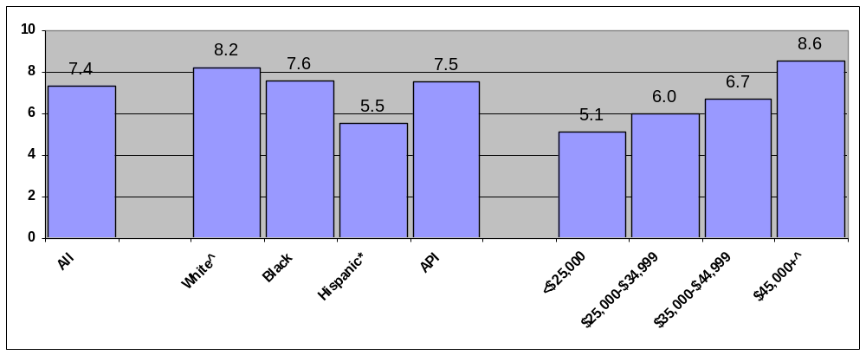
^ Indicates reference group.
* p<0.05 and relative rate >10% for comparison of group with reference group.
Key: API=Asian or Pacific Islander
Source: Agency for Healthcare Research and Quality, Healthcare Cost and Utilization Project State Inpatient Databases 16-State database, 2000.

Figure 2. Accidental laceration or puncture during procedure per 1,000 discharges 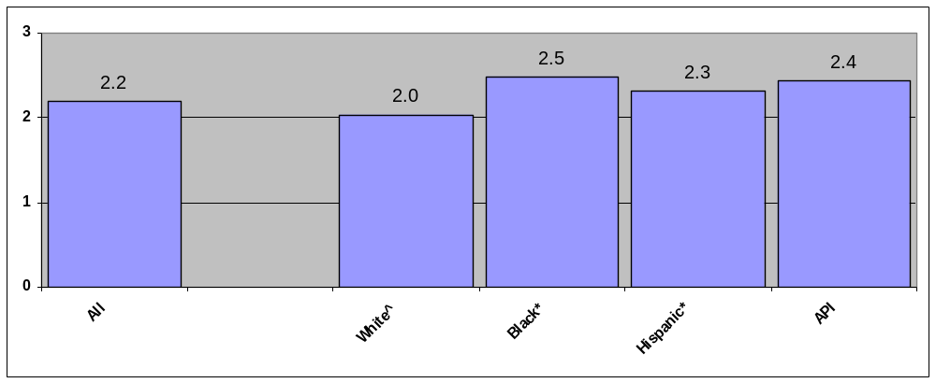
^ Indicates reference group.
* p<0.05 and relative rate >10% for comparison of group with reference group.
Key: API=Asian or Pacific Islander
Source: Agency for Healthcare Research and Quality, Healthcare Cost and Utilization Project State Inpatient Databases, 16-State database, 2000.

Medication safety

Among children, the percentage of persons with a provider who does not usually ask about medications and treatments other doctors may give is higher among blacks (86%) than whites (78%) and higher among Hispanics (85%) than non-Hispanic whites (77%) (MEPS, 1999).

Access to Care

Traditional measures and data sources on children’s access to health care are limited. Not all traditional measures of mainstream health care (e.g., care provided in physicians’ offices, hospitals, and emergency departments) are tailored to children’s health care needs. Moreover, children sometimes get needed services outside the mainstream health care system, such as in schools, public specialty clinics, and from non-physician subspecialists. Mainstream efforts to collect data on children’s health care rarely collect information about these sources of health care. As a result, little is known about how and where many children obtain many health services and about the extent to which there may be disparities among children.

This section focuses on factors that relate to initial contact with the health care system that aid or hinder entry into the system. These measures cover health insurance coverage, usual source of care, and unmet need.

Health insurance

Over 1 out of 5 children spends some time being uninsured. Hispanic children (41%) are considerably more likely than non-Hispanic white children (17%) to have been uninsured for part of the year (Figure 3). Three in 10 poor and near poor children and 19% of middle income children spend time being uninsured, compared with 10% of children in high income families. More than a quarter of all children experience public health insurance coverage for at least some period over the course of a year, and children are less likely than the general population to lack coverage either all year or at any point during the year (MEPS, 1999).

About one quarter of children, mostly poor and near poor, have public coverage any time during the year. Children who are AI/AN (55%) and black (46%) are far more likely to have public coverage than white children (21%). Hispanic children (39%) are more likely to be publicly insured than non-Hispanic children (23%). Nearly three quarters of poor children and 2 in 5 near poor children have public coverage, compared with 3% of children in high income families (MEPS, 1999).

Figure 3. Percent of children with any period of uninsurance during the year
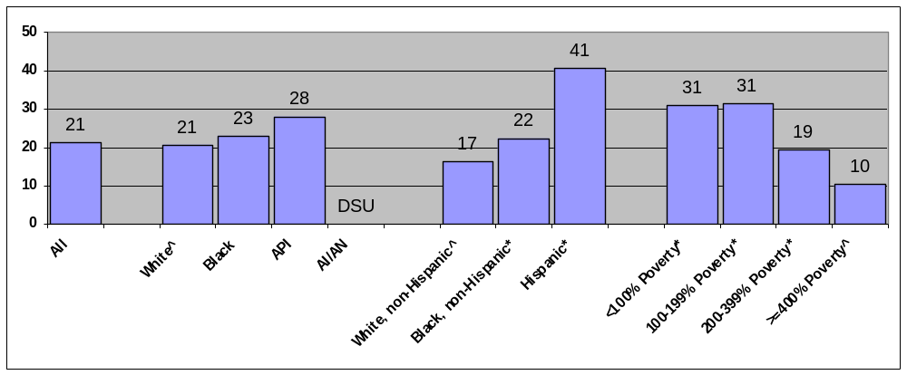
^ Indicates reference group.
* p<0.05 and relative rate >10% for comparison of group with reference group.
Key: API=Asian or Pacific Islander; AI/AN=American Indian or Alaska Native
DSU=Data do not meet the criteria for statistical reliability, data quality, or confidentiality.
Source: Agency for Healthcare Research and Quality, Medical Expenditure Panel Survey, 1999.

Usual source of care

The American Academy of Pediatrics asserts that having a usual source of care or “medical home” is an essential element of effective pediatric care. About 93% of children are reported to have a usual primary care provider. However, API children (81%) are less likely to have a usual primary care provider than white children (88%). Hispanic children of any race (75%) are less likely than non-Hispanic white children (91%) to have a usual primary care provider. Finally, poor children (81%) are less likely than high income children (93%) to have a usual source of primary care (MEPS, 1999).

About 20% of children report that their source of ongoing care is a clinic, outpatient department or a hospital emergency department (Figure 4). AI/AN (49%) and black (28%) children are more likely than white (17%) children to report these settings as their source of ongoing care. Hispanic children of any race (28%) are more likely than non-Hispanic white children (15 percent) to report these facilities as their source of ongoing care, as are poor (30%) versus high-income (12%) children (NHIS, 2000).

Patient perceptions of inadequate access and need

The percent of children who can always get an appointment for routine care as soon as desired is lower among Hispanics (45%) than non-Hispanic whites (54%) and among poor (48%), near poor (45%), and middle income (52%) children compared with high income children (58%) (MEPS, 2000).

Figure 4. Percent of children who identify a hospital, emergency room, or clinic as their source of ongoing care
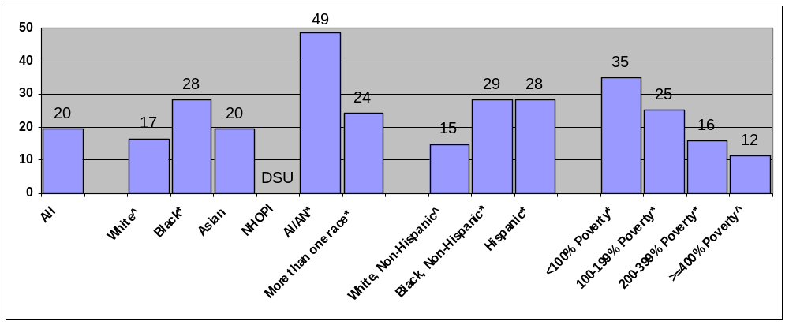
^ Indicates reference group.
* p<0.05 and relative rate >10% for comparison of group with reference group.
Key: NHOPI=Native Hawaiian or Other Pacific Islander; AI/AN=American Indian or Alaska Native
Source: National Center for Health Statistics, National Health Interview Survey, 2000.

Getting care

Scheduling appointments in off-peak hours is a less frequent option for black (50%) and AI/AN (52%) children than white children (62%). Hispanic children (54%, vs. 64% of non-Hispanic white children) and poor children (52%, vs. 67% of high income children) are also less likely to have access to off-peak appointments (MEPS, 1999).

Satisfaction with professional staff at the usual source of care’s office is an indicator of the ability to obtain care. Families of children who are APIs (38%) and AI/ANs (32%, vs. 24% of whites), Hispanic (29%, vs. 23% of non-Hispanic whites), and poor (29% vs. 22% of high income children) are more likely to report dissatisfaction with the professional staff at their child’s usual health care delivery site (MEPS, 1999).

Among children, no racial or ethnic disparity is noted in difficulty obtaining referral to a specialist. However, poor and near poor children are more likely to report difficulty obtaining a referral compared with high income children.

Waiting times

Once at the doctor’s office, children who are black (19%, vs. 15% of whites), Hispanic (25%, vs. 13% of non-Hispanic whites), and poor (26%, vs. 18% of near poor, 16% of middle income, and 10% of high income children) are more likely to wait more than 30 minutes to see their usual source of care. Black children (33%) are also more likely than white children (25%) to have an hour or more wait for semi-urgent or non-urgent emergency department care (MEPS, 1999). There are insufficient data to determine disparities among other groups of children for this measure and similarly inadequate data to determine if there are disparities in wait times at hospital emergency departments among different groups of children needing urgent or emergent care.

Patient-provider communication

Families of black (86%, compared with 78% of white), Hispanic (85%, vs. 77% of non-Hispanic white), and poor (84%, vs. 78% of high income) children are more likely to report that their “usual source of care asks about prescription medications and treatments other doctors may give” (MEPS, 1999)

Patient-provider relationship

Data on overall satisfaction with health care provided to children are reported by parents or other adults responding on behalf of children. Eleven percent of parents overall rate their children’s health care relatively low (<= 6 on a 0-10 scale). Black (14%) compared to white (10%) and poor (19%) compared with high income (6%) families are more likely to report dissatisfaction with their children’s health care on this scale (MEPS, 2000).

Receipt of health care

Among children, many racial and ethnic minorities as well as persons of lower socioeconomic position are less likely to receive office or outpatient visits, prescription medications, and dental visits. For example, among children, blacks (58%) and APIs (62%) are less likely than whites (74%), Hispanics (61%) are less likely than non-Hispanic whites (76%), and poor children (65%) are less likely than high income children (79%) to receive an office visit (MEPS, 1999).

Significant racial disparities in referred care are not evident among children. However, visits in which the patient was referred by another physician or health plan are received less often by uninsured children (7%) than by children with private insurance (12%) (NAMCS/NHAMCS, 1999-2000).

Among children, rates of emergency department visits are higher among blacks (54 per 100 population) and lower among APIs (17 per 100) compared with whites (35 per 100) (NHAMCS-ED, 1999-2000).

Avoidable admissions

Avoidable admissions (also called “admissions of ambulatory care sensitive conditions”) are hospitalizations for health conditions that, in the presence of comprehensive primary care, rarely require hospitalization. High rates of avoidable admissions suggest impaired access to or quality of ambulatory care.

Among children, non-Hispanic blacks typically have higher rates of avoidable admissions while APIs typically have lower rates than non-Hispanic whites. In addition, rates of admission for bacterial pneumonia are higher among Hispanic children (200 per 100,000 population 18 and over) compared with non-Hispanic white children (147 per 100,000) (HCUP SID, 2000).

Elderly

Introduction

The aging of our population poses significant health care, economic, and social challenges. Studies document the growing prevalence of disease, disability, and dependency in the elderly population. Increased need for long-term care and treatment for chronic conditions are likely to place a strain on individuals, families, and the health care infrastructure, even without the added burden resulting from disparities associated with demographic characteristics.

About 1 in 20 Americans requires assistance with activities of daily living, and approximately 2 out of 3 disabled elderly persons live in community settings—which require timely long-term care as well as appropriate access to health care services. Today’s elderly population is confronted with inadequate access to long-term care, and estimates of expected demand in the next 10 years depict a dire situation for those needing nursing home beds and home health care.

Since the 1965 enactment of the Medicare program, nearly all elderly persons have been covered by a core health insurance package. This insurance greatly reduces one significant barrier to health care—the ability to pay for acute care services. However, because Medicare does not completely eliminate cost as a barrier to health care, and other obstacles continue to affect the ability of the elderly to get timely and appropriate treatment of their health care needs, significant disparities in access to and utilization of health care among the elderly remain.

The impact of factors affecting access to and use of health care on racial, ethnic, and low income populations are well known. Among the elderly, the vulnerable subgroups include racial and ethnic minorities, individuals with low income, beneficiaries without supplemental insurance, and the oldest old (i.e., persons aged 85 or older). All of these groups have or are susceptible to disparities in access to and utilization of medically needed health care, particularly because many of these subgroups are growing faster than the Medicare population as a whole.

Surveys of the general population often do not include enough elderly to permit assessment of many disparities. Therefore, the NHDR supplements its analysis with data from the Medicare Current Beneficiary Survey (MCBS, 1999). MCBS data allow comparisons of elderly beneficiaries who have Medicare and Medigap coverage with beneficiaries who have only Medicare fee-for-service coverage. The analysis presented here focuses on Medicare beneficiaries aged 65 and over who reside in the community.

Quality of Care

This section evaluates quality of health care for the elderly in terms of effectiveness, safety, timeliness, and patient centeredness. It also identifies which areas health care quality varies among female subpopulations.

Effectiveness

Health care is “effective” when appropriate, proven medical services and treatments are provided to all who could benefit and not provided to those unlikely to benefit. The following discussion of health care effectiveness for the elderly provides an overview of treatment patterns that can help identify data needs and suggest additional areas for future research.

Cancer

As in the general population, minorities and low socioeconomic status elderly are less likely to receive many cancer screening services. However, while Hispanic women generally are less likely to receive mammograms and Pap smears compared with non-Hispanic white women, these differences disappear among seniors. The percent of elderly women who report they had a mammogram within the past two years is the same for both Hispanics and non-Hispanic whites (68%), while the percent who report they had a Pap smear in the past three years is similar for Hispanics (67%) and non-Hispanic whites (64%) (NHIS, 2000).

Cancer treatment

Within the general population, women who are black and of lower socioeconomic status tend to have higher rates of death from cancer, while API, AI/AN, and Hispanic women tend to have lower rates. Lung cancer and breast cancer death rates follow different trends among the elderly than among the population as a whole. Specifically, while blacks generally have higher mortality rates from lung and breast cancer than whites, death rates from lung cancer are not significantly different between elderly blacks (329 per 100,000 population) and elderly whites (323 per 100,000). Likewise, death rates from breast cancer among elderly black women (132 per 100,000) do not significantly differ from the rates among and elderly white women (123 per 100,000) (National Vital Statistics System-Mortality (NVSS-M), 2000).

Heart disease

Disparities in screening for cardiovascular risk factors differ between the general population and the elderly. While there is no evidence for disparity in cholesterol screening among the general population, elderly blacks (84%) are less likely than whites (88%) to have had their blood cholesterol checked in the preceding 5 years. There are no significant disparities in blood pressure measurement noted among the elderly (NHIS, 1998).

Data on management of congestive heart failure from the National Hospital Discharge Survey (NHDS) indicate that rates of potentially avoidable hospital admissions for congestive heart failure increase with age, and differences between blacks and whites tend to attenuate (Figure 5).

Figure 5. Hospital admissions for congestive heart failure per 100,000 population by age and race 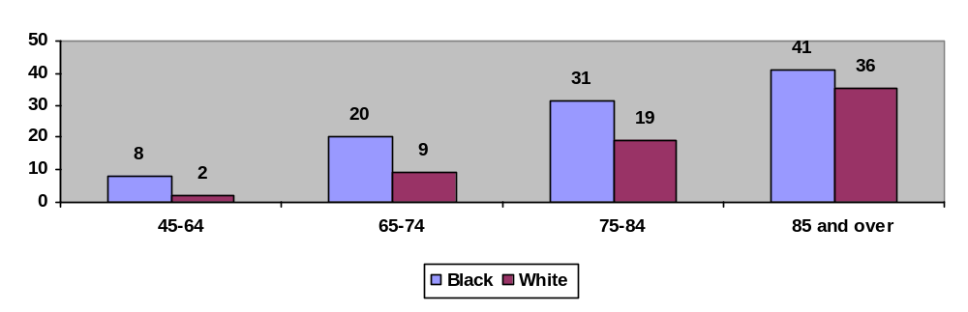
Source: National Center for Health Statistics, National Hospital Discharge Survey, 2000.

HIV/AIDS

Data on new AIDS cases indicate that disparities in HIV/AIDS are generally larger among the elderly than among younger age groups. Among the elderly, new AIDS cases are being reported at a higher rate by non-Hispanic blacks (15.1 per 100,000 population) and Hispanics (5.9 per 100,000) than by non-Hispanic whites (0.7 per 100,000), and relative rates tend to be higher than in the general population (CDC’s HIV/AIDS Surveillance System, 2000).

Data on HIV-infection deaths indicate similar disparities. Overall HIV infection death rates are higher among blacks and Hispanics. Among the elderly, HIV infection death rates are also higher among blacks (9.4 per 100,000 population) compared with whites (0.7 per 100,000) and among Hispanics (2.8 per 100,000) compared with non-Hispanic whites (0.5 per 100,000); but again, relative effects sizes are larger (NVSS-M, 2000).

Respiratory diseases
Research indicates that vaccination against flu among the elderly results in lower rates of hospitalization, mortality, and complications, as well as cost savings. However, elderly blacks and persons of lower socioeconomic position are less likely to receive influenza and pneumococcal immunization. Among persons 65 and over, receipt of influenza vaccine is less often reported by blacks (48%) than by whites (66%), by the poor (56%) and near poor (61%) than by high income families (69%), and by persons with less than a high school education (58%) and high school graduates (66%) than by persons with any college education (70%) (see Chapter 3). Among persons age 65 and over, receipt of influenza vaccine is also less often reported by Hispanics (56%) than by non-Hispanic whites (67%) (NHIS, 2000).

Data on immunization of nursing home residents from the National Nursing Home Survey (NNHS) only allow for comparisons of blacks to whites due to small sample sizes. In the total adult nursing home population, the black-white difference in the percent of residents who have ever received pneumococcal vaccination is not statistically significant. However, this measure is significantly different between blacks (29%) and whites (39%) age 75 to 84 and between blacks (32%) and whites (41%) age 85 and over (NNHS, 1999).

Long-term care

Data on nursing facility care from CMS’s Nursing Home Resident Profile Table contain information on all current Medicare nursing home residents (~1.4 million residents). In the total nursing home population, non-Hispanic blacks and Hispanics are more likely than non-Hispanic whites to have bed sores. As the prevalence of bed sores increases with age among minorities, these differences tend to grow larger (Figure 6).

Figure 6. Percent of nursing home residents with bed sores by age and race/ethnicity
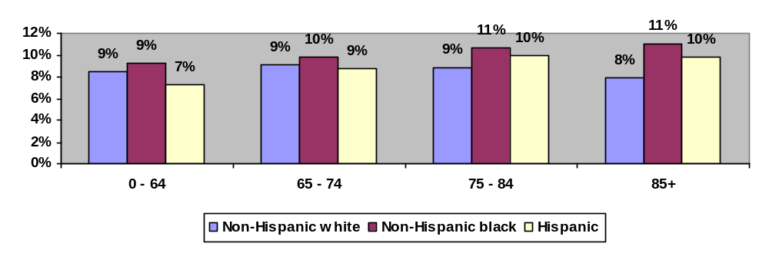
Source: Centers for Medicare & Medicaid Services Nursing Home Resident Profile Table.

In the total nursing home population, Hispanics and APIs are more likely than non-Hispanic whites to be restrained but non-Hispanic blacks are not more likely to be restrained. In contrast, among nursing home residents age 85 and older, non-Hispanic blacks, Hispanics, and APIs are all more likely to be in restraints compared with non-Hispanic whites (Figure 7).

Figure 7. Percent of nursing home residents in restraints by age and race/ethnicity
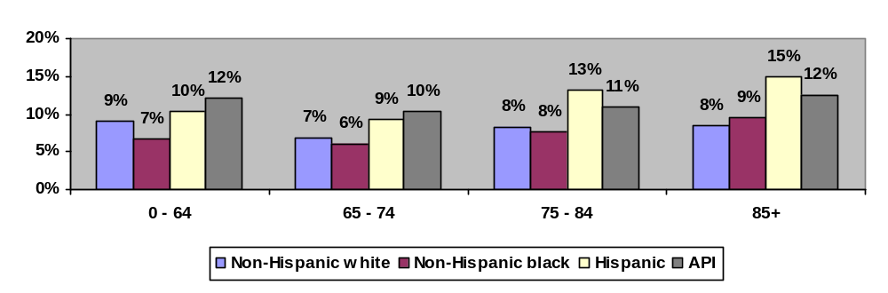
API=Asian or Pacific Islander
Source: Centers for Medicare & Medicaid Services Nursing Home Resident Profile Table.

Patient Safety

This report has previously noted that medical errors are the eighth leading cause of death in the Nation. Two aspects of patient safety among the elderly are discussed here: inpatient safety and medication safety.

Inpatient safety

When disparities among hospitalized elderly are identified, they typically parallel disparities in the general population. However, several exceptions are noted. Among all hospitalized patients, rates of decubitus ulcers are higher among non-Hispanic blacks compared with non-Hispanic whites. As the frequency of these pressure ulcers increases with age, differences tend to grow larger (Figure 8). In addition, among the elderly, Hispanics also have higher rates of decubitus ulcers compared with non-Hispanic whites (HCUP SID 16-State database, 2000).

Among hospitalized patients, rates of death in low mortality DRGs are not significantly different between non-Hispanic blacks and non-Hispanic whites. Among the elderly, this measure is higher among non-Hispanic blacks (3.9 per 1,000 admissions in low mortality DRGs) compared with non-Hispanic whites (3.5 per 1,000).

Medication safety

Data on medication safety from MEPS indicate that the use of inappropriate medications among the elderly do not indicate significant disparity.

Figure 8. Decubitus ulcers per 1,000 selected stays of 4 or more days
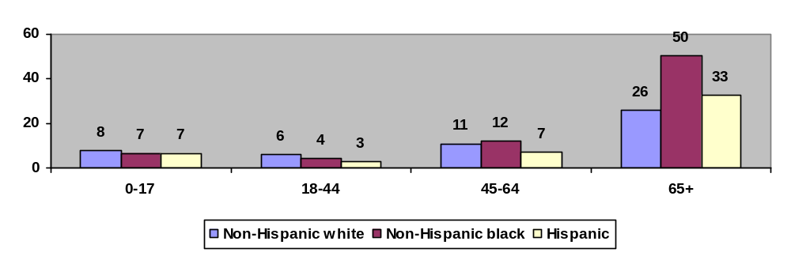

Source: Agency for Healthcare Research and Quality, Healthcare Cost and Utilization Project State Inpatient Databases 16-State database, 2000.

Timeliness and Patient Centeredness

In general, the elderly encounter fewer problems with sources of care and delays in getting care. Seniors who are minorities or of low socioeconomic status, however, do wait longer to be seen in doctor’s offices and emergency rooms.

The elderly generally report problems with patient-provider relationship and communication less often than younger age groups. Disparities related to patient centeredness tend to decrease with age.

Access to Care

The impact of factors affecting access to and use of health care on racial, ethnic, and low income populations has been widely documented. Many of the vulnerable elderly groups are growing faster than the Medicare population as a whole. Between 1992 and 1998, the Medicare population grew at an average annual rate of 1.5% compared to 6.3% for Hispanics, 9.8% for non-Hispanic minorities, and 3.4% for the oldest old. Other barriers also continue to affect the ability of the elderly to get timely and appropriate treatment for their health care needs.

Health insurance

Patterns of health insurance coverage among the population age 65 and over are considerably different from patterns among the general population. Since the 1965 enactment of the Medicare program, nearly all elderly persons have been covered by a core health insurance package; in contrast, only 83% of younger persons are insured. This insurance greatly reduces one barrier to health care—the ability to pay for acute care services.

However, Medicare does not completely eliminate cost as a barrier to health care. For example, elderly patients often have out-of-pocket expenses for prescription medications and doctor bills. In response to these gaps, many elderly opt to augment their Medicare coverage with supplemental private health insurance plans.

Usual source of care

MCBS findings confirm the presence of race/ethnic and socioeconomic disparities in access to care among the elderly. For example, the percent of the elderly with no usual source of care is higher among blacks (7.8%) compared with whites (5.1%), Hispanics (8.4%) compared with non-Hispanic whites (4.9%), poor (7.5%) and near poor (6.3%) compared with those with high incomes (4.0%), and elderly with only Medicare (17.5%) compared with those with both Medicare and Medigap coverage (4.6%).

Similarly, the percent who delay care due to cost is higher among poor (6.8%), near poor (7.3%), and middle income (2.8%) elderly than high income elderly (1.2%), as well as among the elderly with only Medicare (12.1%) compared with elderly who have both Medicare and Medigap coverage (3.0%).

Finally, the percent experiencing problems getting to the doctor is higher among poor (7.8%), near poor (5.5%), and middle income (4.0%) elderly than high income elderly (2.4%), as well as among the elderly with only Medicare (6.3%) compared with those covered by both Medicare and Medigap (3.7%) (MCBS, 1999).

While the elderly are more likely than younger age groups to have a regular or usual source of ongoing care, prominent disparities are associated with race, ethnicity, and socioeconomic position. As in the general population, elderly minorities are more likely to have a hospital, emergency room, or clinic as their source of ongoing care (21% of elderly blacks vs. 13% of elderly whites, and 21% of elderly Hispanics vs. 12% of elderly non-Hispanic whites). Utilization of these potentially suboptimal sources of care is also higher among the elderly who are poor (21%), near poor (17%), or middle income (14%) compared with the elderly who have higher incomes (10%) (NHIS, 2000).

Patient perceptions of inadequate access and need

The elderly report fewer difficulties or delays in obtaining health care than younger persons, but there are discernible socioeconomic differences. For example, elderly persons with less than a high school education (6%) are more likely to report having difficulty in obtaining care than those who have attended college (2%). Similarly, the elderly who did not complete high school (23%) and those who ended their education after high school graduation (18%) are more likely to report dissatisfaction with getting needed health care than their peers who attended college (13%) (MEPS, 1999).

Getting care

Compared with younger groups, the elderly are more likely to report having difficulties obtaining referrals to specialists than younger populations. These problems are reported more frequently by racial and ethnic minorities and by the poor. Elderly blacks (76%) are less likely to report no problems obtaining specialist referrals than elderly whites (89%), and elderly Hispanics (84%) are less likely to report no problems obtaining specialist referrals than elderly non-Hispanic whites (89%). Similarly, the elderly poor (84%) are less likely to report no problems obtaining specialist referrals than the elderly with high incomes (90%) (MEPS, 2000).

Waiting times

There is evidence of racial/ethnic and socioeconomic differences in waiting times among the elderly. The following elderly subgroups experience longer waiting times at their usual source of care: blacks (27%) and APIs (10%) compared with whites (16%); Hispanics (31%) compared with non-Hispanic whites (16%); and poor (24%) compared with high income elderly (16%) (MEPS, 1999).

Patient-provider communication

Within the elderly population, racial, ethnic, and socioeconomic disparities exist in patient-provider communication. Black seniors (27%) are more likely than white seniors (13%) and elderly Hispanics (31%) are more likely than elderly non-Hispanic whites (11%) to have had poor communication with their provider during their last visit, as indicated by one or more indicators (Commonwealth Fund Health Care Quality Survey, 2001). Similarly, the elderly with less than a high school education (23%) are more likely than the elderly with any college education (13%) to report poor communication with their provider during their last visit, as measured by one or more indicators.

On the other hand, elderly Hispanics (88%) and blacks (81%) are more likely than elderly non-Hispanic whites (76%) or whites (77%) to report that their usual sources of care inquires about treatments prescribed by other doctors (MEPS, 1999).

Patient-provider relationship

While the elderly tend to rate their health care higher than younger groups, there are disparities among the elderly. Disparities among elderly subgroups in rating their health care less favorably (from 0 to 6) on a ‘0 to 10 scale’ are seen as follows: elderly blacks (20%) and APIs (16%) compared with elderly whites (10%); the elderly poor (14%) compared with those with high incomes (7%); and the elderly with less than a high school education (15%) compared with those who attended at least some college (7%) (MEPS, 2000).

Disparities also exist between race/ethnic groups when respondents are asked if they felt as involved in decisionmaking as they wanted to be. Specifically, 30% of elderly blacks compared with 14% of whites and 36% of elderly Hispanics compared with 13% of non-Hispanic whites report not being involved in decisionmaking as much as they wanted (Commonwealth Fund Health Care Quality Survey, 2001).

Cultural competency

Data from the Commonwealth Fund Health Care Quality Survey indicate that the elderly are more likely than younger groups to agree that their doctor understood their background and values, and significant disparities associated with demographic characteristics are not apparent.

Health information

Generally, the elderly are less likely to seek out health information and to have more difficulty understanding information provided by their doctors. Disparities among the elderly are similar to disparities noted among younger groups. For example, elderly Asians (55%) have more difficulty than elderly whites (47%) in understanding health care information provided by their physicians. Similarly, 63% of the elderly with less than a high school education compared to 45% of high school graduates and 40% of those who attended college have more difficulty obtaining health care information than those with college educations (Commonwealth Fund Health Care Quality Survey, 2001).

Receipt of health care

Disparities in the receipt of health care associated with race, ethnicity, and socioeconomic status observed in the general population tend to lessen among the elderly.

The elderly are more likely to receive most types of services, and disparities in the receipt of health care observed among younger populations are reduced. Disparities in ambulatory care are similar between the elderly and younger age groups. However, the significance is often lost due to small sample sizes. One exception may be rates of outpatient visits among blacks. In the general population, rates are lower among blacks (262 per 100 population) compared with whites (333 per 100). Among the elderly, rates of outpatient visits are higher. In addition, rates are similar between blacks (614 per 100 population) and whites (643 per 100) (NAMCS/ NHAMCS, 1999-2000). Data on referred care from NAMCS/NHAMCS indicate significant racial disparities in referred care among the general population, but these are not seen among the elderly.

In the general population, non-Hispanic blacks, Hispanics, and APIs typically have lower rates of high variation surgeries. Among the elderly, these disparities typically persist. One exception may be in rates of hysterectomy. In the general population, admission rates are higher among non-Hispanic blacks (560 per 100,000 female population age 18 and over) compared with non-Hispanic whites (487 per 100,000). In contrast, among the elderly, rates are lower among non-Hispanic blacks (131 per 100,000 female population age 18 and over) compared with non-Hispanic whites (191 per 100,000).

Data on chronic care from the National Home and Hospice Care Survey (NHHCS) and the National Nursing Home Survey only provide black-white comparisons due to small sample size. Among the elderly, rates of home health and nursing home discharge are similar between blacks and whites, while rates of hospice discharge are lower among blacks (890 per 100,000 population) compared with whites (1,425 per 100,000).

Mental health care and substance abuse treatment

Data on mental health care and substance abuse treatment from National Household Survey on Drug Abuse (NHSDA) do not allow assessment of disparities among the elderly due to small sample sizes.

HIV care

Data on HIV care from the HIV Research Network do not allow assessment of disparities among the elderly due to small sample sizes.

Avoidable admissions

Non-Hispanic blacks typically have higher rates of avoidable admissions while APIs typically have lower rates compared with non-Hispanic whites in the general population. Among the elderly, these disparities typically persist. One exception may be in rates of admission for bacterial pneumonia. In the general population, admission rates of Hispanics and non-Hispanic whites are similar, but among the elderly, rates are lower among Hispanics (1,313 per 100,000 population) compared with non-Hispanic whites (1,630 per 100,000) (HCUP SID 16-State database, 2000).

Medicare Current Beneficiary Survey (MCBS) Studies

Because surveys of the general population often include inadequate numbers of the elderly to assess many disparities, analyses of the MCBS were conducted to better understand disparities in access to health care among the elderly. The MCBS allows comparisons between elderly beneficiaries with Medicare and Medigap coverage and beneficiaries with only Medicare fee-for-service coverage. The analysis presented here focuses on Medicare beneficiaries age 65 and over who reside in the community.

In general, MCBS findings confirm the presence of racial/ethnic and socioeconomic disparities in access to care among the elderly. For example, the percent of the elderly with no usual source of care is higher among blacks (7.8%) compared with whites (5.1%), Hispanics (8.4%) compared with non-Hispanic whites (4.9%), poor (7.5%) and near poor (6.3%) compared with high income persons (4.0%), and elderly with only Medicare (17.5%) compared with those covered by both Medicare and Medigap (4.6%).

Similarly, the percent who delayed care due to cost is higher among the poor (6.8%), near poor (7.3%), and middle income (2.8%) elderly compared with high income elderly (1.2%) and among the elderly with only Medicare (12.1%) compared with those who have both Medicare and Medigap coverage (3.0%).

Finally, the percent experiencing problems getting to the doctor is higher among poor (7.8%), near poor (5.5%), and middle income (4.0%) elderly compared with high income elderly (2.4%) and among the elderly with only Medicare (6.3%) compared with those covered by both Medicare and Medigap (3.7%).

Racial and Ethnic Subpopulations

Introduction

The U.S. population has become increasingly diverse in terms of national origin over the last three decades. In 2002, an estimated 28 million documented residents were foreign born; the actual number is undoubtedly higher, given the recent increase in illegal immigration. Although previous chapters of this report describe health care disparities by racial and ethnic categories (as defined by the Office of Management and Budget and used by the U.S. Census Bureau), these aggregate figures fail to capture important variances among subsets of some primary groups. This section provides a look at health care disparities in subsets of three primary racial and/or ethnic groups: (1) the large and heterogeneous Hispanic population (based on place of origin); (2) the smaller but equally disparate Asian population; and (3) the approximately 60% of American Indian and Alaska Natives who receive care from Indian Health Services (IHS) facilities.

While disparities in health care for minority populations can be linked to levels of income and education, limited English proficiency (LEP) and cultural differences are important source of barriers. The 2000 census found that close to half of persons age 5 and over who speak a foreign language have difficulty communicating in English, and 4.7% of persons age 5 and over live in households where English is not routinely spoken.

Numerous studies have shown the negative effect of LEP on health care. For example, non-English speaking patients are more likely than English-speaking consumers to rely on emergency rooms for primary care; non-English-speaking women who skipped the Pap test for cervical cancer said that educational materials on the procedure were unavailable or inadequate; and asthmatic patients with limited English skills are more likely than others to break appointments and stop taking their medication.

Cultural differences are also significant causes of miscommunication. People in many parts of the world do not know of or accept the pathogen concept and choose to rely on folk remedies or herbs for treatment. Attitudes about the body and the role of the doctor can pose problems, as can ways of describing illnesses and needs. Proper treatment of behavioral anomalies such as phobias and visions may require understanding reported symptoms within the context of the patient’s culture.

These variables are reflected in the markedly higher proportions of Asian and Hispanic respondents who showed difficulty communicating at their last health visit, when stratified by income and education (see Chapter 4). Only Asians in the highest income group reportedly approximated the communication skills of whites. Looking at these variables among subsets of the selected primary populations can shed light on the nature and dynamics of health care disparities in ethnic minorities.

Federal health care data collections often do not include information about ethnic subpopulations and, when they do, sample sizes tend to be small. In an attempt to help fill this gap, non-Federal data collections were examined; but none was identified that could provide reliable national estimates for subpopulations across a range of health care topics. As a result, and as noted below, findings are not nationally representative of racial and ethnic subpopulations.

Quality and Access for Hispanic Subpopulations

Census 2000 counted over 35 million Hispanics, or 12.5% of the population in the United States, making Hispanics the largest minority group in America. An additional 3.8 million Hispanics live in the Commonwealth of Puerto Rico.

The Hispanic population is highly heterogeneous. Mexicans are the largest Hispanic subpopulation in the United States, accounting for almost 60% of Hispanics, followed by Puerto Ricans, Central Americans and South Americans. Among Hispanics, variation in access to and quality of health care has been observed related to place of origin and degree of acculturation.

To help tease apart these differences, AHRQ identified a State database, the 2001 California Health Interview Survey (CHIS), which includes large numbers of Hispanic subpopulations. California is home to more Hispanics (i.e., 11 million) than any other State; and CHIS included over 10,000 Hispanics in its sample design. In addition, CHIS was conducted in six languages, including Spanish, and collected information about languages spoken at home—which is used as a proxy for acculturation.

This section identifies disparities in access to and, to a limited extent, quality of health care between Hispanics and non-Hispanic whites, among different Hispanic subpopulations related to place of origin, and among Hispanics related to language.

Quality of Care

In California, the NHDR identifies disparities in quality of health care between Hispanics and non-Hispanic whites, among different Hispanic subpopulations related to place of origin, and among Hispanics related to language. For example, the percent of persons age 50 and over who ever had flexible sigmoidoscopy or colonoscopy is lower among Hispanic Californians (39%) compared with non-Hispanic white Californians (58%) (Figure 9). In addition, among Hispanics, this measure ranges from 32% for Central Americans to 51% for South Americans. This measure is also lower among Hispanics who speak Spanish only at home (29%) and Spanish and English at home (39%) compared with Hispanics who speak English only at home (50%).
Figure 9. Percent of Californians 50 and over who ever had flexible sigmoidoscopy or colonoscopy by ethnicity, place of origin, and language
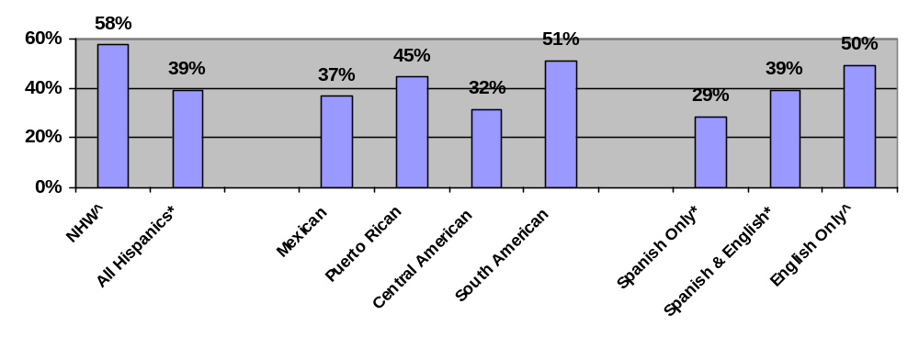
^Indicates reference group.
* p<0.05 for comparison of group with reference group. Note that no comparisons are made among Hispanics by place of origin.
Key: NHW=non-Hispanic white
Source: California Health Interview Survey, 2001.

Similarly, the percent of persons age 65 and over that received influenza vaccination in the past 12 months is lower among Hispanic Californians (54%) than non-Hispanic white Californians (70%) (Figure 10). In addition, among Hispanics, influenza vaccination ranges from 41% for Central Americans to 58% of Mexicans. Hispanics who speak Spanish only at home (50%) and Spanish and English at home (54%) are less likely to receive the vaccination than Hispanics who speak English only at home (66%).

Access to Care

Health insurance

The percent of persons with health insurance is lower among Hispanic Californians (74%) compared with non-Hispanic white Californians (93%) (Figure 11). In addition, among Hispanics, this measure ranges from 66% for Central Americans to 91% for Puerto Ricans. This measure is also lower among Hispanics who speak Spanish only at home (58%) and Spanish and English at home (76%) compared with Hispanics who speak English only at home (89%) (CHIS, 2001).

Figure 10. Percent of Californians 65 and over who received influenza vaccination in the past 12 months by ethnicity, place of origin, and language
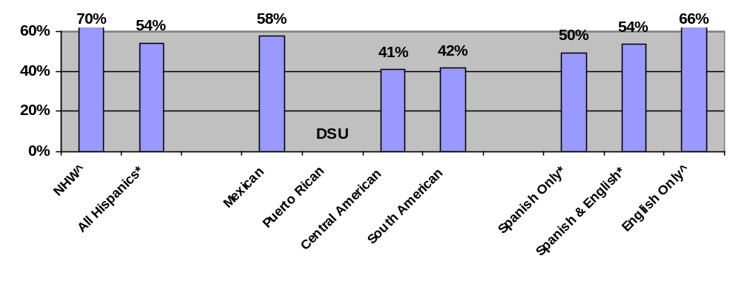
^ Indicates reference group.
* indicates p<0.05 for comparison of group with reference group. Note that no comparisons are made among Hispanics by place of origin.
Key: NHW=non-Hispanic white
DSU=Data do not meet the criteria for statistical reliability, data quality, or confidentiality.
Source: California Health Interview Survey, 2001.

Figure 11. Percent of Californians with health insurance by ethnicity, place of origin, and language
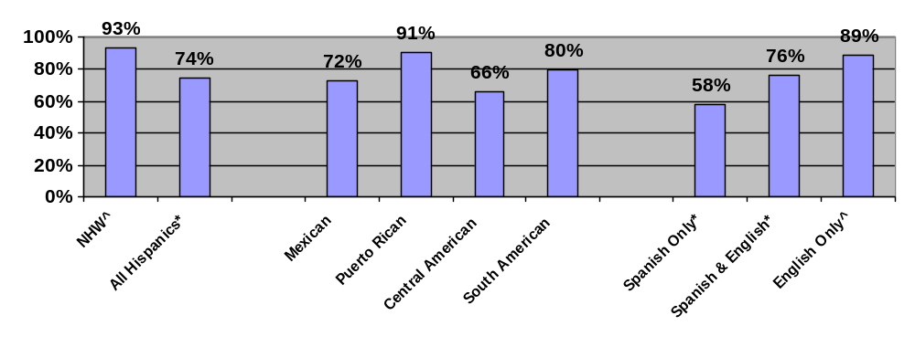^Indicates reference group.
* p<0.05 for comparison of group with reference group. Note that no comparisons are made among Hispanics by place of origin.
Key: NHW=non-Hispanic white
Source: California Health Interview Survey, 2001.

Usual source of care

Similarly, the percent of persons with a source of ongoing care is lower among Hispanic Californians (82%) compared with non-Hispanic white Californians (91%) (Figure 12). In addition, among Hispanics, this measure ranges from 78% for Central Americans to 89% of Puerto Ricans. This measure is also lower among Hispanics who speak Spanish only at home (73%) and Spanish and English at home (84%), compared with Hispanics who speak English only at home (88%).

Figure 12. Percent of Californians with source of ongoing care by ethnicity, place of origin, and language
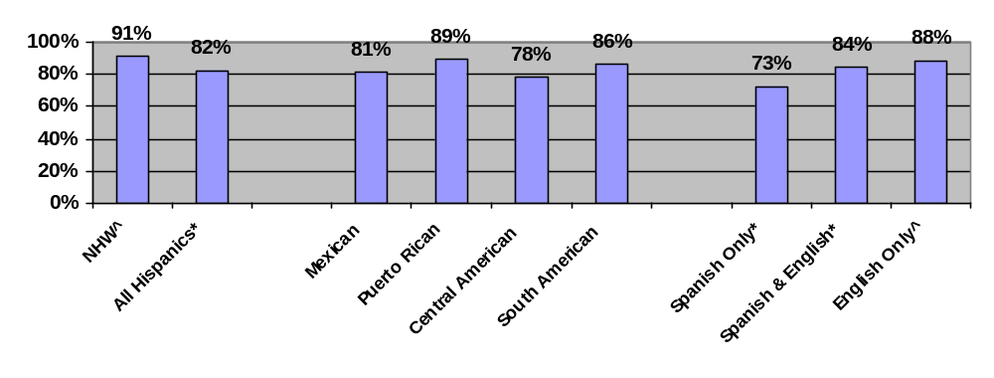
^Indicates reference group.
* p<0.05 for comparison of group with reference group. Note that no comparisons are made among Hispanics by place of origin.
Key: NHW=non-Hispanic white
Source: California Health Interview Survey, 2001.

Patient perceptions of inadequate access and need

In contrast, the percent of persons who experience delays in medical care is lower among Hispanic Californians (15%) than among non-Hispanic white Californians (23%) (Figure 13). In addition, among Hispanics, this measure ranges from 13% for Mexicans to 24% for Puerto Ricans. This measure is also lower among Hispanics who speak Spanish only at home (11%) and Spanish and English at home (14%) compared with Hispanics who speak English only at home (20%).

Figure 13. Percent of Californians who experience delays in medical care by ethnicity, place of origin, and language
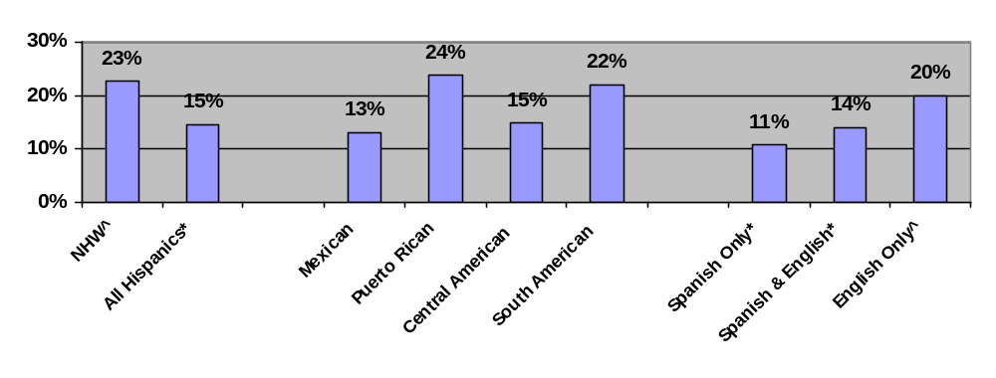
^Indicates reference group.
* p<0.05 for comparison of group with reference group. Note that no comparisons are made among Hispanics by place of origin.
Key: NHW=non-Hispanic white
Source: California Health Interview Survey, 2001.

Because Federal health care data collections typically do not collect information on the patient-provider relationship, cultural competency, and health information, the NHDR uses the Commonwealth Fund Health Care Quality Survey to provide national estimates. In 2001, this survey included over 1,100 Hispanics and collected information about Hispanic subpopulations, and was conducted in five languages (including Spanish). The Commonwealth Fund survey included questions about languages spoken at home—which is used as a proxy for acculturation.

Patient-provider relationship

The percent of persons not treated with a great deal of dignity and respect, a measure of the patient-provider relationship, is not significantly different between Hispanics (24%) and non-Hispanic whites (23%) (Figure 14). However, among Hispanics, this measure ranges from 16% of Puerto Ricans to 34% of Central Americans. This problem is also reported less often by Hispanics who speak primarily Spanish at home (12%) than Hispanics who speak primarily English at home (31%).

Cultural competency

Similarly, the percent of persons who do not strongly agree that their doctor understands their background and values, a measure of cultural competency, is not significantly different between Hispanics (38%) and non-Hispanic whites (40%) (Figure 15). However, among Hispanics, this measure ranges from 34% of Central Americans to 41% of Mexicans. This problem is also reported less often by Hispanics who speak primarily Spanish at home (31%) than by Hispanics who speak primarily English at home (43%).

Figure 14. Percent of persons not treated with a great deal of dignity and respect by ethnicity, place of origin, and language
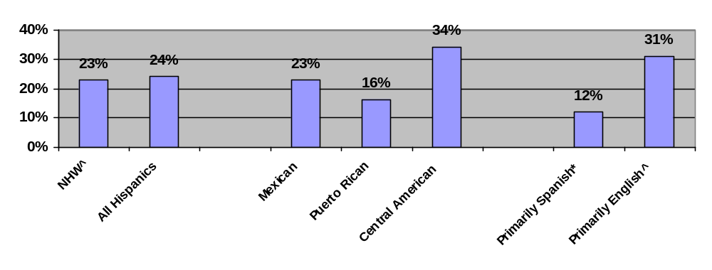

^Indicates reference group.
* p<0.05 for comparison of group with reference group. Note that no comparisons are made among Hispanics by place of origin.
Key: NHW=non-Hispanic white
Source: Commonwealth Fund Health Care Quality Survey, 2001.

Figure 15. Percent of persons who do not strongly agree that their doctor understands their background and values by ethnicity, place of origin, and language
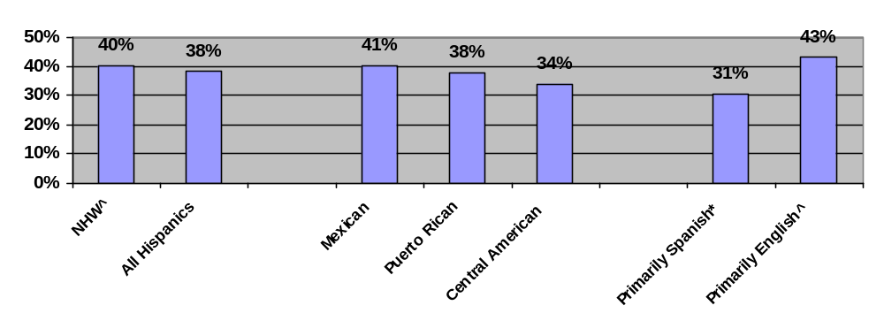
^Indicates reference group.
* p<0.05 for comparison of group with reference group. Note that no comparisons are made among Hispanics by place of origin.
Key: NHW=non-Hispanic white
Source: Commonwealth Fund Health Care Quality Survey, 2001.

Health information

In contrast, the percent of persons who do not find it very easy to understand information from their doctor’s office is higher among Hispanics (54%) than non-Hispanic whites (40%) (Figure 16). In addition, among Hispanics, this measure ranges from 40% of Puerto Ricans to 58% of Mexicans. This problem is also reported more often by Hispanics who speak primarily Spanish at home (63%) than Hispanics who speak primarily English at home (48%).

Figure 16. Percent of persons who do not find it very easy to understand information from their doctor’s office by ethnicity, place of origin and language
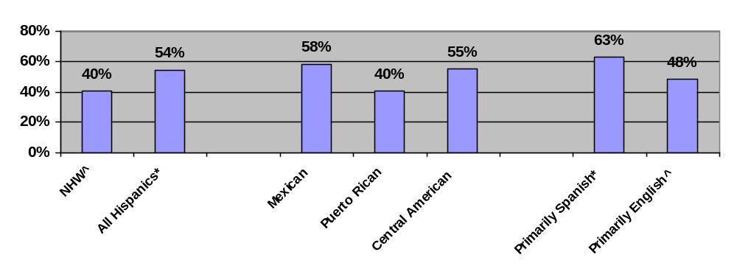
^Indicates reference group.
* p<0.05 for comparison of group with reference group. Note that no comparisons are made among Hispanics by place of origin.
Key: NHW=non-Hispanic white
Source: Commonwealth Fund Health Care Quality Survey, 2001.

Quality and Access for Asian Subpopulations

Census 2000 counted almost 12 million Asians, or 4.2% of the population, in the United States. Asians are the fastest growing racial group in America. As with the Hispanic population, the Asian population is highly heterogeneous. Among Asians, differences in health care have been observed related to place of origin. Differences have also been observed related to degree of acculturation.

No databases were identified that could provide reliable national estimates for Asian subpopulations for the topics covered in this report; but again the California Health Interview Survey, which includes large numbers of Asian subpopulations, was identified. California is the home to more Asians (i.e., 4.2 million) than any other State, and CHIS included almost 6,500 Asians in its sample design, including oversampling of Japanese, Vietnamese, South Asians, Koreans, and Cambodians. In addition, CHIS was conducted in six languages including Chinese, Vietnamese, Korean, and Khmer and collected information about languages spoken at home. Languages spoken at home are used as a proxy for acculturation and differentiate Asians who speak Asian languages only at home, Asian languages and English at home, and English only at home. This section presents data on access to care and quality of care among Asian subpopulations from CHIS in 2001.

Quality of Care

In California, disparities exist in measures of quality of health care between Asians and whites, among different Asian subpopulations related to place of origin, and among Asians related to language. For example, the percent of persons age 50 and over who ever had flexible sigmoidoscopy or colonoscopy is lower among Asian Californians (44%) than white Californians (57%) (Figure 17), ranging from 36% of Vietnamese to 56% of Japanese. Asian Californians who only speak Asian languages at home (37%) and those who speak both Asian languages and English at home (42%) are less likely to have had flexible sigmoidoscopy or colonoscopy than Asians who speak English only at home (57%).

Figure 17. Percent of Californians 50 and over who ever had flexible sigmoidoscopy or colonoscopy by select race categories, place of origin, and language
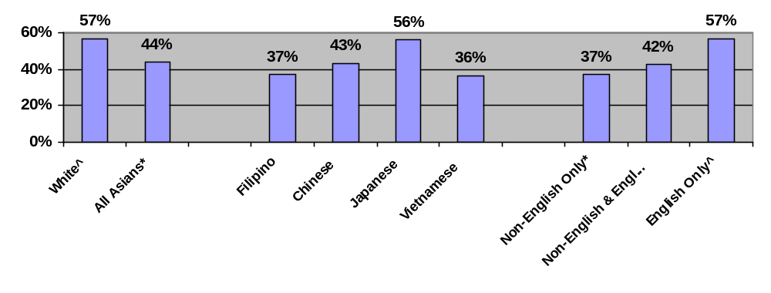
^Indicates reference group.
* p<0.05 for comparison of group with reference group. Note that no comparisons are made among Asians by place of origin.
Source: California Health Interview Survey, 2001.

Similarly, the percent of women age 18 and over who had a Pap smear in the past 3 years is lower among Asian Californians (72%) than white Californians (86%) (Figure 18), ranging from 63% of Vietnamese to 81% of Filipinos. Asian Californians who only speak Asian languages at home (56%) and those who speak both Asian languages and English at home (73%) are more likely to have had a Pap smear in the last 3 years compared with Asians who speak English only at home (81%).

Figure 18. Percent of Californian women 18 and over who had a Pap smear in the past 3 years by select race categories, place of origin, and language
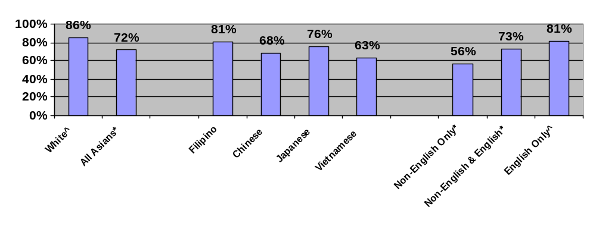^Indicates reference group.
* p<0.05 for comparison of group with reference group. Note that no comparisons are made among Asians by place of origin.
Source: California Health Interview Survey, 2001.

Access to Care

Health insurance

In California, disparities in access to health care are noted between Asians and whites, among different Asian subpopulations related to place of origin, and among Asians related to language. For example, the percent of persons with health insurance is lower among Asian Californians (88%) compared with white Californians (90%) (Figure 19). In addition, health insurance coverage among California’s Asian population ranges from 85% of Vietnamese to 94% of Japanese. Health insurance is less common among those who only speak Asian languages at home (78%) and those who speak both Asian languages and English at home (88%) compared with Asians who speak English only at home (92%).

Usual source of care

Similarly, Asian Californians are less likely than white Californians to have a source of ongoing care (Figure 20). Asians who only speak Asian languages than at home are less likely (80%) Asians who only speak English at home (90%) to have a source of ongoing care.
Figure 19. Percent of Californians with health insurance by select race categories, place of origin, and language
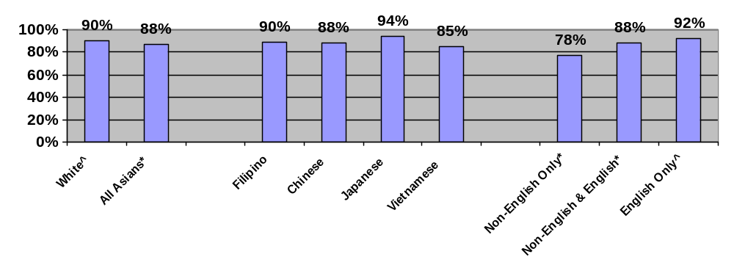^ Indicates reference group.
* p<0.05 for comparison of group with reference group. Note that no comparisons are made among Asians by place of origin.
Source: California Health Interview Survey, 2001.

Figure 20. Percent of Californians with source of ongoing care by select race categories, place of origin, and language
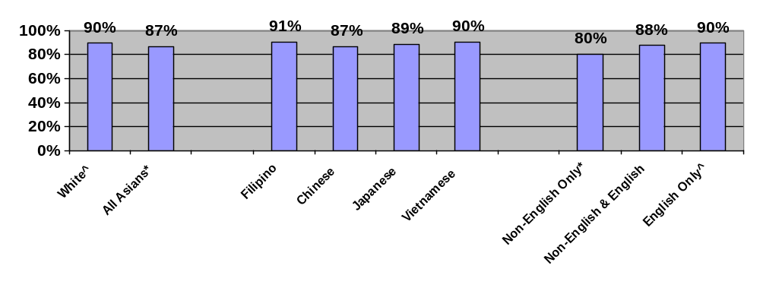^ Indicates reference group.
* p<0.05 for comparison of group with reference group. Note that no comparisons are made among Asians by place of origin.
Source: California Health Interview Survey, 2001.

The NHDR uses the Commonwealth Fund Health Care Quality Survey to provide national estimates on measures of the patient-provider relationship, cultural competency, and health information among Asian subpopulations and identifies differences between Asians and whites and among different Asian subpopulations. In 2001, this survey included over 600 Asians and collected information about Asian subpopulations. In addition, it was conducted in five languages including Chinese, Korean, and Vietnamese.

Patient-provider relationship

The percent of persons not treated with a great deal of dignity and respect is higher among Asians (40%) than whites (23%) (Figure 21). Furthermore, not all Asians respond similarly: Filipinos are much less likely to report that they were treated with respect (27%) than Vietnamese respondents (47%).

Figure 21. Percent of persons not treated with a great deal of dignity and respect by select race categories and place of origin
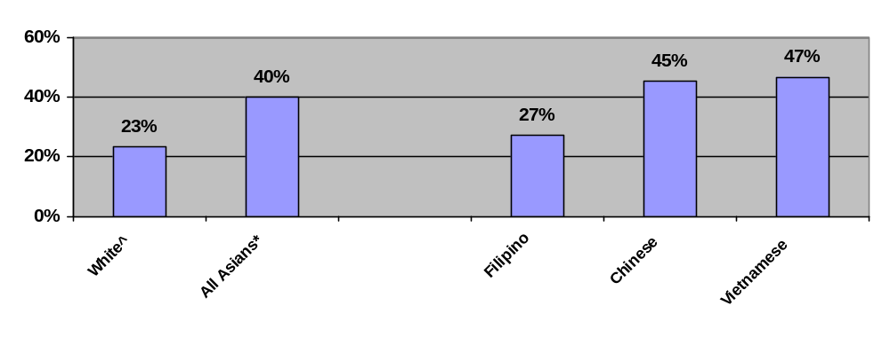
^Indicates reference group.
* p<0.05 for comparison of group with reference group. Note that no comparisons are made among Asians by place of origin.
Source: Commonwealth Fund Health Care Quality Survey, 2001.

Cultural competency

Similarly, the percent of persons who do not strongly agree that their doctor understands their background and values is higher among Asians (51%) than with whites (40%) (Figure 22) and is reported differently by different subgroups—ranging from 39% of Filipinos to 55% of Chinese.

Figure 22. Percent of persons who do not strongly agree that their doctor understands their background and values by select race categories and place of origin

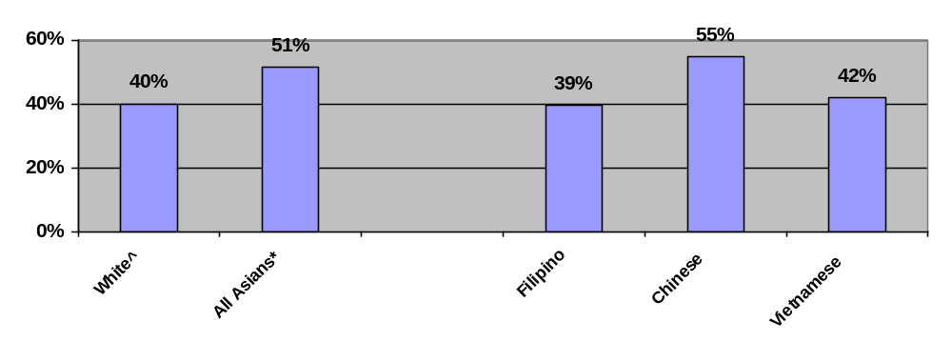
^Indicates reference group.
* p<0.05 for comparison of group with reference group. Note that no comparisons are made among Asians by place of origin.
Source: Commonwealth Fund Health Care Quality Survey, 2001.

Health information

Finally, the percent of persons who do not find it very easy to understand information from their doctor’s office is higher among Asians (58%) than whites (42%) (Figure 23). In addition, among Asians, this problem ranges from 46% of Filipinos to 74% of Vietnamese.

Figure 23. Percent of persons who do not find it very easy to understand information from their doctor’s office by select race categories and place of origin
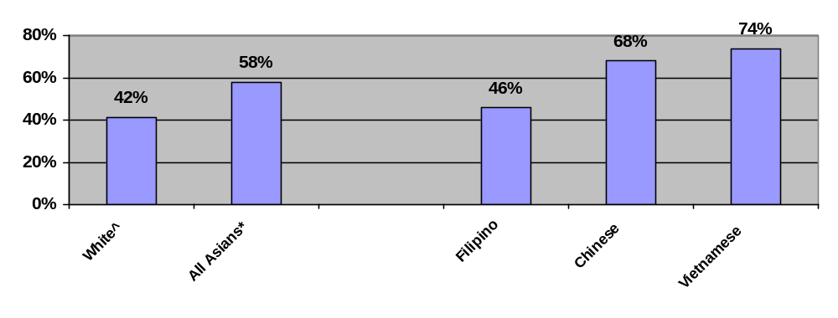 ^ Indicates reference group.
* p<0.05 for comparison of group with reference group. Note that no comparisons are made among Asians by place of origin.
Source: Commonwealth Fund Health Care Quality Survey, 2001.
Quality and Access for American Indians and Alaska Natives

There are slightly over 2 million self-identified American Indians and Alaska Natives in the United States, with only 38% that continue to reside on Federal trust lands. Over 30% of the AI/AN population falls below the poverty standard, experiencing unemployment rates that are 2.5 times that of the national average. Lower life expectancy and a disproportionate disease burden exist, perhaps due to inadequate education, disproportionate poverty, geographic isolation, service delivery problems, and cultural differences.

Of all AI/ANs nationwide, approximately 60% rely on the Indian Health Service (IHS) to provide access to health care. The IHS serves populations in 35 States through a network of 12 areas that operate over 500 facilities. The IHS service population is predominantly rural. The disproportionate incidence of disease and conditions experienced by this population increases the costs of delivering care. Because life-threatening disease and injury get first priority, patients with less severe problems find their medical care may be postponed or simply never carried out. For example, cardiovascular disease has become a major source of disability, increasing hospitalizations and both inpatient and outpatient procedures, resulting in significantly increasing expenditures for IHS and Tribal Contract Health Service funds. A need for aggressive treatment and prevention activities has been recognized by Tribes as well as the IHS.

Among persons with diabetes being served by IHS facilities, 93% had a hemoglobin A1c measurement done in the past year, and 53% received an annual flu vaccine, not unlike the rates experienced by the overall U.S. diabetic population. However only 53% received a retinal eye exam in the past year compared to 67% for the overall U.S. diabetic population, and only 55% received a foot examination in the past year, compared to the overall U.S. diabetic rate of 66%.

The annual IHS per capita personal health care expenditure for AI/ANs in fiscal year 2001 was $1,730 compared with $4,392 for the overall U.S. population— a 39% lower per capita expenditure than that for the U.S. population as a whole. A study by managed care organizations showed the average cost of caring for a person with diabetes ranges from $5,000-$9,000 annually. More than $150 million is spent annually by the IHS on the treatment of injuries, may be reduced by implementation of effective injury prevention programs, in turn making additional resources potentially available for the treatment of other health conditions.

Researchers examining medical care expenditures found only 1 in 3 AI/ANs has private health insurance, compared with 80% of U.S. whites. According to the 1999 Federal Employees Health Benefit Plan (FEHBP) Disparity Index study, IHS funding is only 60% of the funding provided by mainstream employer-provided plans. In trying to account for the disparities, health care experts, policymakers, and tribal leaders are looking into funding and other factors that affect health care delivery to AI/ANs.

There are significant disparities experienced by American Indians and Alaska Natives residing in areas served by the IHS — males can expect to live 6 years less than the average U.S. male and AI/AN females can expect to live 5 years less than the average U.S. female. Infant mortality rates among AI/ANs are 24% higher than the total U.S. population. Mortality rates experienced by AI/ANs are disparate with overall U.S. rates: mortality rates are 67% higher due to alcohol-related causes, 318% higher for diabetes, 180% higher mortality rates due to accidents, 92% higher due to suicide, and 110% higher due to homicide.,

Rural Populations
Introduction

According to the U.S. Bureau of the Census, more than 60 million people live in rural areas, and roughly 55 million live in “non-metropolitan counties.” Americans in these areas face specific challenges to accessing, utilizing, and paying for quality health care. Access to specialty care can be particularly difficult due to a limited (and diminishing) supply of health care delivery sites. Many facilities that rural residents have grown to rely upon, including small rural hospitals, have either closed or are in serious financial straits.

Among these few delivery sites, the supply of health care providers in rural areas is smaller per capita than other areas. While 20% of Americans live in rural areas, only 9% of the Nation's physicians practice in rural areas. Loan forgiveness and other programs that seek to recruit and retain health care clinicians in shortage areas are facing difficult times, in part because funding sources for such initiatives have grown unstable.

Transit and transportation needs are also pronounced among rural populations, who face longer distances to reach health care delivery sites—particularly when seeking specialty or dental care. Usually, rural areas have no public transportation infrastructure. Residents of frontier counties, where there is a low population density, find it particularly difficult to access and receive health care where it is required that one travel over long distances or have long travel times to reach sources of care. Of the 940 frontier counties, most have few health care services and 78 do not have any at all.

The unique demographics of rural areas augment the challenges of providing high-quality health care. Compared with their urban counterparts, rural populations are disproportionately elderly and less affluent, more likely to describe their health as poor or fair and to lack private health insurance, and receive care in a less timely fashion., ^{, 8} Furthermore, low population density makes it difficult to deliver services that target persons with special health care needs. Groups at particular risk include: the elderly, the poor, those living with AIDS or HIV infection, the homeless, mothers with children and adolescents, racial and ethnic minorities, those living with disabilities, the uninsured, and agricultural workers.

Difficulties accessing and receiving health care may help explain some of the adverse health outcomes experienced by rural residents. Residents of the Nation’s most rural counties experience the highest death rates for children and young adults, as well as the highest mortality for ischemic heart disease and suicide among men. Although inadequate controls in research on this topic make it difficult to argue that rurality alone significantly impacts health, rural minorities appear to be particularly disadvantaged in cancer screening and management, cardiovascular disease, and diabetes as compared with their urban counterparts.

This section applies the NHDR measure set to residents of rural, non-Metropolitan Statistical Area (MSA) counties. It is the first step to understanding disparities in quality and access to care among rural populations. Yet significant gaps exist. Many health care needs and services of importance to rural populations are not addressed. In addition, sample size limitations become a significant problem as the general population is subdivided into small groups. Hence, these findings should not be interpreted as a comprehensive assessment of disparities in health care among rural populations.

Quality of Care

Effectiveness of Care

Most measures of effectiveness included in the quality of care measure set are applicable to the rural population, although small sample sizes become an analytic impediment. In addition, measures related to chronic kidney disease, HIV/AIDS, mental health, and long term care could not distinguish urban and rural residents. In general, disparities observed in the general population were also observed when examining rural residents; yet few differences were observed in the measure of effectiveness related to diabetes and heart disease. This section focuses on measures that demonstrate different disparities between rural and urban residents:

- Cancer screening
- Maternal and child health
- Respiratory diseases

Cancer screening

As in the general population, minority and rural residents of lower socioeconomic position are less likely to receive many cancer screening services. Disparities in colorectal cancer screening may be particularly pronounced for some rural residents and reduced for others. Among urban residents, receipt of fecal occult blood testing within the past 2 years is reported at about the same rates by blacks (33%) and whites (34%). In contrast, among rural residents, colorectal screenings are reported less often by blacks (19%) than whites (32%). Among urban residents, receipt of fecal occult blood testing is reported less often by Hispanics (21%) than by non-Hispanic whites (36%). Rural residents, Hispanics (27%), and non-Hispanic whites (32%) have similar rates (NHIS, 2000).

Among rural populations, there do not appear to be any racial or ethnic differences for receipt of Pap screening. However, poor (70%) and near poor (77%) rural women are less likely than high income women (85%) to have received a Pap test within the last 3 years (NHIS, 2000.)

Maternal and child health

Rural maternal and child health data were insufficient to make statistically significant comparisons.

Respiratory diseases

Data on immunization in the general population indicate that blacks and persons of lower socioeconomic position tend to be less likely to receive influenza and pneumococcal immunization. Disparities in immunization may be particularly pronounced for some rural residents and reduced for others. Among urban residents, the percent of high risk persons ages 18 to 64 who received influenza vaccination in the past year is similar across income groups. However, among rural residents, poor (19%) and near poor (24%) persons had lower rates compared with high income persons (32%). On the other hand, urban blacks (25%) had lower rates than urban whites (29%), while rural blacks (26%) and whites (27%) had similar rates (NHIS, 2000).

Patient Safety

Inpatient safety

When disparities among hospitalized rural residents are identified, they typically parallel disparities in the general population. However, there is an exception among all hospitalized patients and hospitalized urban residents, where rates of birth trauma are lower among non-Hispanic blacks compared with non-Hispanic whites. Among rural residents, this measure is higher among non-Hispanic blacks (7.5 per 1,000 live births) compared with non-Hispanic whites (6.2 per 1,000) (HCUP SID, 2000).

Medication safety

In the general population, the percentage of persons with a provider that does not usually ask about medications and treatments other doctors may give is higher among blacks compared with whites and among Hispanics compared with non-Hispanic whites (see Chapter 4). Similarly, among rural residents, this measure is higher among blacks (87%) compared with whites (78%) and among Hispanics (88%) compared with non-Hispanic whites (77%) (MEPS, 1999).

Timeliness and Patient Centeredness

Timeliness is the core need of the health care system to reduce waits and harmful delays for those who receive care. Health care cannot prevent death and disability if it is delivered too late and delays can lead to complications that ultimately increase health care costs. In general, rural residents wait longer periods of time to be seen in a doctor’s office but shorter periods of time to be seen in emergency rooms. Disparities in most measures of timeliness are similar or slightly reduced among rural residents compared with urban residents. Measures of patient centeredness overlap with several concepts discussed in the access section below.

Access to Care

Health insurance

Individuals living outside of MSAs are about as likely as those living inside MSAs to be uninsured. Blacks (35%) and APIs (46%) living in non-metropolitan areas are more likely than non-metropolitan whites (24%) to be uninsured for at least part of the year. Similar to the general population, Hispanics living in non-metropolitan areas (50%) are twice as likely to be uninsured as non-Hispanics (24%). As with the general population, poor, near poor, and middle income individuals (41%, 40%, and 22%, respectively) in non-MSAs are more likely than high income individuals (12%) to be uninsured for at least some period of time. Rural residents with less than a high school education are more likely than those with more than a high school education to be uninsured for at least part of the year (42% vs. 18%, respectively) (MEPS, 1999).

Individuals living in non-MSAs are somewhat more likely to have public insurance coverage than those living in MSAs. In non-metropolitan areas, blacks are more likely than whites (32% vs. 16%) and Hispanics are more likely than non-Hispanic whites (29% vs. 15%) to spend some time enrolled in a public insurance program during the year. As with the general population, rural residents who are poor (51%) or near poor (29%) are more likely to have any public coverage than those with high incomes (3%). Similarly, rural residents with fewer than 12 years of education are more likely to be publicly insured than those with more than 12 years of schooling (25% vs. 4%) (MEPS, 1999).

Usual source of care

Generally, rural and urban populations have similar access to sources of ongoing care, yet disparities observed in the general population typically persist among rural residents. Hispanics and lower income populations fare worse than non-Hispanic whites and high income persons across most “usual source of care” measures in both the general and rural populations. One exception may relate to rural blacks. Data indicate that in urban areas, blacks are more likely to identify a clinic, hospital outpatient department, or emergency room as their source of ongoing care compared with whites. In contrast, in rural areas, blacks and whites have similar rates (NHIS, 2000).

Patient perceptions of inadequate access and need

Generally, unmet needs in rural populations are similar to urban populations, yet disparities observed in the general population typically persist among rural residents. Data indicate that rural Hispanics and lower income individuals are more likely than rural non-Hispanic whites and wealthier populations to experience delays in care and be less satisfied that they can obtain health care should they need it. Also, blacks in rural areas are more likely to report that their families did not receive care or medications because the family needed the money compared with rural whites (MEPS, 1999).

Getting care

Rural and urban populations face similar barriers to getting care with one exception: rural residents report that their provider does not have office hours at night or on weekends more frequently than do urban residents. However, disparities observed in the general population typically persist among rural residents. Data indicate that reporting of problems in obtaining referrals to specialists is higher among rural Hispanics than rural non-Hispanic whites and by lower income rural residents compared with high income rural residents. One exception may relate to the ability of Hispanics to contact their providers to discuss health problems over the telephone. In urban areas, Hispanics are more likely to report problems than non-Hispanic whites, but in rural areas, this problem is experienced about equally by Hispanics and non-Hispanic whites (MEPS, 2000).

Waiting times

Rural residents tend to have longer waiting times to see their provider but shorter waiting times in emergency departments. However, racial/ethnic and socioeconomic disparities in waiting times are similar among rural and urban residents. Only about 16% of the overall population, compared with 21% of the rural population, report waiting more than 30 minutes to see their health care provider. This trend is reversed in hospital settings where 12% of the general population waits an hour or more for care in emergency departments, compared with only 7% of rural residents. Similarly, waiting times of an hour or more for semi-urgent/non-urgent emergency department care are more common among the population at large (26%) compared with the rural population (15%). Race, ethnicity, education, and income disparities in waiting times at doctor’s offices appear to be less significant in the rural population than among the general population (MEPS, 1999).

Patient-provider communication

Patient-provider communication is comparable between urban and rural residents. Disparities in the general population typically persist among rural residents. Data indicate that rural residents with lower incomes and less education are more likely to report indicators of poor communication compared with more affluent rural residents (Commonwealth Fund Health Care Quality Survey, 2001).

Patient-provider relationship

Rural and urban populations have similar perceptions of their relationships with their health care providers. Disparities observed in the general population typically persist among rural residents. Data indicate that the percent of rural residents who rate satisfaction with health care lower (<= d 6 on 0-10 scale) is higher among blacks compared with whites and among lower income and less educated persons compared with more affluent persons (MEPS, 2000).

Cultural competency

Rural residents are more likely to report that their doctor understands their background and values compared with urban residents. Unfortunately, there is too little cultural competency data on rural priority populations to discern if and to what extent health care disparities exist.

Health information

Rural populations are more likely to have problems obtaining and understanding health information. Compared with urban respondents, rural respondents less frequently find information from their doctor’s office that is easy to understand and experience greater difficulty in using the Internet to obtain health information. Disparities observed in the general population typically persist among rural residents: lower income and less educated rural residents have more difficulty finding easy to understand information from their doctor’s office compared with more affluent rural residents.

Receipt of health care

In general, disparities in receipt of health care do not differ between rural and urban residents. In the general population, many racial/ethnic minorities as well as low income and less educated persons are less likely to receive office or outpatient visits, prescription medications, and dental visits. During the past year, office or outpatient visits were less likely to be received by blacks compared with whites, by Hispanics compared with non-Hispanic whites, by persons with lower family incomes compared with persons with higher family incomes, and by less educated persons compared with more educated persons (see Chapter 4). Similarly, among rural residents, office or outpatient visits are less likely to be received by blacks (62%) compared with whites (74%) and by Hispanics (55%) compared with non-Hispanic whites (75%) (MEPS, 1999). The fundamental issue behind these disparities may be attributed to socioeconomic disparities, which are also present among rural residents but tend to be attenuated.

In the general population, rates of emergency department visits and hospitalization are higher among blacks than whites. Among rural residents, rates of emergency department visits are also higher among blacks (70 per 100 population) compared with whites (47 per 100) (NHAMCS-ED, 1999-2000).

Non-Hispanic blacks, Hispanics, and APIs typically have lower rates of utilization for high variation surgeries. For example, rates of PTCA are lower among non-Hispanic blacks (335 per 100,000 population), Hispanics (297 per 100,000), and APIs (195 per 100,000) compared with non-Hispanic whites (535 per 100,000). Also, compared with non-Hispanic whites, APIs have lower rates of Cesarean delivery and higher rates of vaginal birth after cesarean delivery; a disparity persists among rural residents (HCUP SID, 2000).

Mental health care and substance abuse treatment

Data on mental health care and substance abuse treatment come from the National Household Survey on Drug Abuse (NHSDA) where sample sizes do not allow assessment of disparities among rural residents, compounded by the paucity of mental health providers in rural areas.

Avoidable admissions

In the general population, non-Hispanic blacks typically have higher rates of avoidable admissions while APIs typically have lower rates than non-Hispanic whites. Among rural residents, these disparities typically persist. In terms of rates of admissions for chronic obstructive pulmonary disease for urban residents, rates are higher among non-Hispanic blacks (271 per 100,000 population 18 and over) than non-Hispanic whites (241 per 100,000); but overall rates in rural populations are higher: the rate for non-Hispanic blacks is 320 per 100,000 population 18 and over compared with a rate of 379 per 100,000 for non-Hispanic whites (HCUP SID, 2000).

Individuals with Special Health Care Needs

Introduction

Persons with special health care needs may be particularly vulnerable to disparities in health care. Though somewhat constrained by the availability of data, four populations with special health care needs are examined:

- Children with special health care needs
- Persons with disabilities
- Persons who utilize long term care
- Persons at the end of life.

This section applies relevant NHDR measures to individuals with special health care needs. These findings are supplemented with some analyses from the Medicare Current Beneficiary Survey. The measures used include some measures specific to these individuals, but many health care needs and services of importance to each of these populations are not addressed. In addition, since sample size limitations are a significant problem among subgroups of the general population, these findings should not be interpreted as a comprehensive assessment of disparities in health care among the individuals with special health care needs.

Children with Special Health Care Needs

Background

The term “children with special health care needs” (CSHCN) was first used in the Omnibus Budget Reconciliation Act of 1989, replacing earlier categories such as “crippled,” “handicapped,” “disabled” or “chronically ill.” The broader classification provides a framework that focuses on common goals and needs, especially concerning services administered through the Maternal and Child Health Bureau (MCHB) of the Health Resources and Services Administration in States and territories. With the focus on prevention, functional limitations, and increased medical needs, the MCHB defines CSHCN as those who have or are at increased risk for chronic physical, developmental, behavioral, or emotional conditions and who also require health and related services of a type or amount beyond that required by most children.

The prevalence of CSHCN is estimated to fall between 10% and 20% of theNnation’s 72.5 million children. CSHCN often have a higher need for health and rehabilitative services, such as services from specialty physicians, mental health providers, or physical, speech, or occupational therapists; or personal assistance for developing children. As provision of health care services evolves, access to well-coordinated care that includes the development of relationships that support family caregivers is particularly important in providing effective care to this population.

Currently, parents of CSHCN report problems obtaining needed care for their children, including obtaining referrals, finding a provider with the needed skill and experience to provide care, and getting the number of visits needed for their child’s care, as well as the family’s out-of-pocket cost for services and poor coordination of the services. There are few studies addressing racial and ethnic disparities within CSHCN; however, racial/ethnic disparities in access to care, having a usual source of care, rates of unmet need, and dissatisfaction with services have been identified.²

Data on CSHCN are examined for access measures of patient perceptions of inadequate access and need, patient-provider communication, and the patient-provider relationship.

Patient perceptions of inadequate access and need

In general, CSHCN have greater unmet care needs than other children. However, among CSHCN, disparities in unmet need are noted. Among CSHCN, the percent of children who always can get appointments for routine care as soon as wanted is higher among blacks (55%) than whites (43%). Significant differences in the percent of children who always can get care for illness or injury as soon as wanted are not noted (MEPS, 2000).

Patient-provider communication

Disparities in patient-provider communication among CSHCN are also noted. Among CSHCN, the percent of children whose providers always listened carefully to them is higher among blacks (75%) than whites (60%) (MEPS, 2000).

Patient-provider relationship

Finally, disparities in patient-provider relationships among CSHCN are also noted. Among CSHCN, the percent of children who rate their health care 6 or worse on a scale from 0 to 10 is higher among children in poor households (32%) compared with children in high income households (12%) (MEPS, 2000).

Persons with Disabilities

Background

There are multiple ways of defining and measuring disability. Two of the more common approaches are to identify functional activity limitations or to identify those meeting the criteria for eligibility for a program, such as Social Security Disability Insurance (SSDI), that addresses disability. A particular challenge in reporting on racial/ethnic and socioeconomic disparities related to disability is that many data collections do not capture disability and, when collected, do not have adequate sample sizes of the disabled to examine racial/ethnic and socioeconomic disparities.

Analyses of recent trends in disability and functioning among older adults have shown improvements in the last decade, with the prevalence of having any disability declining significantly during the 1990s. However, there are considerable gaps in availability of measures and understanding of trends in disparities across major racial and ethnic groups with respect to functional limitations in the elderly population. About 5.6 million beneficiaries under age 65 qualified for Medicare in 2001, and that number is expected to grow to more than 9 million by 2020. The non-elderly disabled beneficiaries are more likely to have lower income and difficulties accessing care than their elderly Medicare counterparts.⁵

Data on persons with disabilities are examined below in quality of care and access to care, including patient perceptions of inadequate access and need and utilization of care.

Quality of Care

In general, MCBS findings indicate the presence of racial/ethnic and socioeconomic disparities in quality of health care among disabled persons. Among the disabled elderly, the percent of persons who report problems with quality of care is higher among APIs (11%) compared with whites (4%) and among persons in poor households (6%) compared with persons in high income households (3%). Small sample sizes preclude assessment of disparities in quality of health care among the disabled non-elderly.

Access to Care

In general, data indicate the presence of racial, ethnic, and socioeconomic disparities in access to health care among disabled persons. For example, among the disabled elderly, the percent of persons with a problem getting to the doctor from home is higher among Hispanics (16%), compared with non-Hispanic whites (7%). In addition, there is an income gradient with this measure of physical access to a doctor: persons in poor (11%), near poor (9%), and middle income (7%) households experience more difficulty than persons in high income households (4%) (MCBS, 1999).

Among the disabled, blacks (12%) and Hispanics (12%) are less likely to report delayed care due to cost compared with whites (20%) and non-Hispanic whites (21%), respectively (MCBS, 1999).

Persons Who Utilize Long-Term Care

Background

Long-term care is the provision of personal, social, and medical services to persons who have functional or cognitive limitations in their ability to perform self-care and other activities necessary to live independently. It includes the provision of services at home, in the community, and in special facilities. As the number of elderly Americans increases from 35 million in 2000 to an estimated 71 million in 2030, long-term care is expected to increase.

Long-term care includes home health care that is available for those who can be managed at home. In 1996, about 12,000 home health care agencies provided care and 7.8 million persons completed episodes of care. About two-thirds of home health care discharges are elderly.

For those with serious disabilities requiring 24-hour care and needs that can often be better met in a special facility, nursing homes are an option. In 1999, there were 1.6 million nursing home residents residing in 18,000 nursing homes. Just over half of nursing home residents are age 85 and over. Activities of daily living measure a person’s ability to perform six basic self-care tasks: bathing, dressing, eating, transferring from a bed to a chair, toileting, and walking. On average, residents need help with 4.4 activities of daily living. Nursing home care costs $56,000 per year, and expenditures totaled almost $80 billion in 1998, about half of which were paid by Medicaid and Medicare. About 70% of nursing home residents are supported in part by Medicaid.

In recent years, use of home health care and of nursing home care has declined. However, because growth in the elderly population has outpaced growth in the supply of nursing home beds, nursing homes are caring for older patients with more functional limitations.

Racial, ethnic, and socioeconomic disparities in nursing home care have been documented. Differences in the management of pain and the receipt of rehabilitative services among nursing home residents have been demonstrated.

Quality of Care

Disparities in quality of long-term care are present. Two types of care are examined: immunization of nursing home residents, which reflects medical care received by nursing home residents, and quality of nursing home care.

Immunization

Data on immunization of nursing home residents from the NNHS are sparse, allowing only comparison of blacks with whites. Significant disparities in influenza vaccination are not observed, but disparities in pneumococcal vaccination among some nursing home residents are present. Specifically receipt of influenza vaccination is significantly lower among black women (21%) compared with white women (36%) as well as lower among blacks than whites in two ages groups: 29% of blacks vs. 39% of whites ages 75 to 84 and 32% of blacks vs. 41% of whites ages 85 and over (NNHS, 1999).

Quality of nursing home care

Again, disparities are noted, and racial and ethnic minorities have more favorable care on some measures and less favorable care on others. The percent of nursing home residents with pain is lower among non-Hispanic blacks (7%), Hispanics (7%), and APIs (5) compared with non-Hispanic whites (10%). However, the percent of residents in physical restraints is higher among Hispanics (12%) and APIs (12%) compared with non-Hispanic whites (8%) (CMS’s Nursing Home Resident Profile Table).

Access to Care

Due to sample size constraints, the NHDR uses only black-white comparisons for these measures. Among persons ages 65 and over, rates of home health care discharge and nursing home discharge did not differ significantly between blacks and whites. Similarly, among persons ages 18 to 64, rates of home health care discharge did not differ significantly between blacks and whites. However, among persons ages 18 to 64, rates of nursing home discharge are higher among blacks (22 per 10,000 population) compared with whites (16 per 10,000). In addition, when discharged from a nursing home, the percent of persons who were stabilized or recovered is lower among blacks (22%) than to whites (34%) (NHHCS, 2000).
Persons at the End of Life

Background

The quality of life and the quality of health care for individuals who are approaching the end of life is an integral and important part of the delivery of health care. As in other aspects of health care delivery, the social, cultural, and economic structure of the American health care system affects the experience of dying. Nationally, only 25% of deaths occur at home, although more than 70% of Americans say that this is where they prefer to die. About half of all deaths in the United States occur in hospitals, but less than 60% of hospitals in any given State offer end-of-life services. Evidence suggests persons living in wealthier areas are more likely to use hospice care.

The Institute of Medicine’s 1997 Approaching Death report emphasized that a significant number of people experience needless suffering, fear, and distress at the end of life. Research has found that many Americans are concerned that: (1) caregivers will overtreat, thereby protracting death by providing clinically inappropriate or care unwanted by the patient; (2) caregivers will underuse effective treatments to relieve pain or other physical or psychological symptoms; and (3) the quality of end-of-life care will not involve adequate pain and symptom management and lack access to supportive care.

End-of-life care includes the period of time during which an individual experiences declining health from an ultimately terminal illness or condition. For many, this period of time should include palliative care which focuses on addressing the control of pain and other symptoms (e.g., nausea, labored breathing, etc.), as well as psychological, social, and spiritual distress.

About one quarter of Medicare’s dollars are spent on 5% of its beneficiaries in the last year of their life, half of which is spent in the last month of life. Racial/ethnic disparities in Medicare expenditures in the last year of life have been documented., In addition, minority Medicare beneficiaries may be more likely to die suddenly with little or no interaction with the health care system before dying.

While more research is needed to understand disparities in end-of-life care associated with age, gender, or income, access to appropriate end-of-life care with effective provider relationships continues to be of great concern. Today we are challenged by the affects of constraints within the health care system on patients, providers and institutions, and the need to address racial/ethnic disparities in end-of-life care, including palliative care.

Quality of Care

At the end of life, disparities in quality of health care are still present. Two measures of quality of palliative care for cancer were examined: (1) percent of people who died of cancer who received hospice care and (2) median length of stay for cancer patients who received hospice care. Low use of hospice and short lengths of stay in hospice among cancer patients would suggest suboptimal palliative care.

Data limitations only allow for black-white comparisons. While median lengths of stay for cancer patients in hospice were similar between blacks and whites, the percent of cancer patients who used hospice care prior to death was lower among elderly blacks (32%) than elderly whites (52%) (NNHS, 1999).

Access to Care

Mean Medicare expenditures in the last year of life were higher among blacks ($31,759) compared with whites ($23,980). Since information on patient income or education is not available from this source, mean expenditures of Medicare beneficiaries who have both Medicare and Medicaid coverage (dual eligibles) was compared with all other Medicare beneficiaries as a crude proxy of socioeconomic position. Mean expenditures of dual eligibles are not significantly different from mean expenditures of other Medicare beneficiaries. These findings persist after stratification by age, gender, and comorbidities.

References

Institute of Medicine of the National Academies, Unequal Treatment.
Income categories for each of the populations described in this chapter are as follows: “poor” is defined as persons with family incomes less than 100% of the Federal poverty threshold; “near poor” is defined as persons with family incomes between 100% and 199% of the Federal poverty threshold; “middle income” is defined as persons with family incomes between 200% and 399% of the Federal poverty threshold; “high income” is defined as persons with family incomes of 400% or more of the Federal poverty threshold.
U.S., Congress, S.580, see Sec. 901(b)1)(F), methods for measuring quality and strategies for improving quality; Sec. 901(c)(2) Process to Ensure Appropriate Research; Sec. 902 (a)(2)quality measurement and improvement; Sec. 912 (a) Support for Efforts to Develop Information on Quality; and Sec. 914, Information Systems for Health Care Improvement.
Institute of Medicine of the National Academies, Guidance for the National Healthcare Disparities Report. Washington, DC: National Academies Press, 2002, pp. 13-19; 27-35.
“Poor” is defined as persons with family incomes less than 100% of the Federal poverty threshold.
“Near poor” is defined as persons with family incomes between 100% and 199% of the Federal poverty threshold.
^{iii} “Middle income” is defined as persons with family incomes between 200% and 399% of the Federal poverty threshold.
“High income” is defined as persons with family incomes of 400% or more of the Federal poverty threshold.
Poor areas” are defined as having ZIP Codes with median incomes of under $25,000.
“Near-poor areas” are defined as having ZIP Codes with median incomes of $25,000-$34,999.
“High-income areas” are defined as having ZIP Codes with median incomes of $45,000 and higher.
Children are defined differently in different measurement sets. Unless otherwise noted, children are defined in the NHDR as they are defined in the MEPS and the NHIS: 0 through 17 years old.
“Poor areas” are defined as having ZIP Codes with median incomes of under $25,000.
“Near-poor areas” are defined as having ZIP Codes with median incomes of $25,000-$34,999.
“Medium income areas” are defined as having ZIP Codes with median incomes of $35,000-$44,999.
“High-income areas” are defined as having ZIP Codes with median incomes of $45,000 and higher.
Races include: American Indian or Alaska Native, Asian, black or African American, Native Hawaiian or Other Pacific Islander, and white.
Ethnicity differentiates Hispanics and non-Hispanics. The NHDR also distinguishes non-Hispanic whites and non-Hispanic blacks.
Virtually no data sources routinely record language spoken at home, place or birth, or length of time in this country.
For Census 2000, the Census Bureau's classification of "rural" consists of all territory, population, and housing units located outside of urban areas (UAs) and urban clusters (UCs). The Census Bureau classified as "urban" all territory, population, and housing units located within: - Core census block groups or blocks that have a population density of at least 1,000 people per square mile, and - Surrounding census blocks that have an overall density of at least 500 people per square mile. See www.census.gov/geo/www/ua/ua_2k.html for more detail.
? The Office of Management and Budget (OMB) classifies metropolitan counties as having a population of at least 50,000, or a census-defined urbanized area and a total metropolitan area population of at least 100,000 (alternatively, it could reflect the economic activities of a location meeting this definition).
OMB, Provisional Guidance on the Implementation of the 1997 Standards for Federal Data on Race and Ethnicity, 12/15/00, available at http://www.whitehouse.gov/omb/inforeg/r&e_guidance2000update.pdf.
Secretary Tommy G. Thompson, speaking at the National Council for Families & Television’s Women's Health Summit; January 25, 2002 in Los Angeles, California. See http://www.4women.org/secretary/Jan25-2002.htm
“Women’s Health—Filling the Gaps.” Editorial by Catherine D. DeAngelis and Margaret Winker. JAMA, March 21, 2001. Vol. 285, No. 11, p. 1508-9.
“Report rates women's health: Improvements needed”; State Legislatures; Denver; Sep 2002.
“Making the Grade on Women’s Health: A National and State-by-State Report Card,” National Women’s Law Center, University of Pennsylvania and Oregon Health and Science University, 2001. P. 7.
Health People 2010: Understanding and Improving Health, p. 11.
Commonwealth Study 2001.
Commonwealth Study 2001.
Hoyert DL, Freedman MA, Strobino DM, Guyer B. Annual summary of vital statistics: 2000. Pediatrics. 2001;108:1241-1255.
Marian F MacDorman; Arialdi M Minino; Donna M Strobino; Bernard Guyer; “Annual summary of vital statistics—2001”; Pediatrics; Evanston; Dec 2002; Volume 110, Issue 6, Part 1, pp. 1037-1052.
“Making the Grade on Women’s Health: A National and State-by-State Report Card,” National Women’s Law Center, University of Pennsylvania and Oregon Health and Science University, 2001. P. 6.
Kohn LT, Corrigan JM, Donaldson M, al. e. To Err Is Human: Building A Safer Health System. Washington, DC: Institute of Medicine; 1999.
Weber AM, Meyn L, Episiotomy use in the United States, 1979-1997. Obstet Gynecol. 2002; 100:1177-1182.
Risa Lavizzo-Mourey and Elizabeth R. Mackenzie, “Cultural Competence: Essential Measurements of Quality for Managed Care Organizations,” Annals of Internal Medicine, 124 (May 15, 1996), 919-21.
Skocpol T. Protecting Mothers and Soldiers.
Hulbert A. The Century of the Child. Wilson Quarterly 1999.
Forest, Christopher B., Lisa Simpson, Carolyn Clancy. “Child Health Services Research: Challenges and Opportunities.” JAMA, June 11, 1997, Vol. 277, No. 22, pp 1787-1793.
Please see http://www.aap.org/advocacy/releases/medicalhome.htm.
Verbugge, LM. Longer life but worsening health? Trends in health and mortality of middle-aged an older persons. Milbank Quartely, 62(3): 475-519.
De Lew, N, Weinick, R. An Overview: Eliminating Racial, Ethnic, and SES Disparities in Health Care. Health Care Financing Review. Summer 2000; 21 (4): 1-7,
Liu, H. and Sharma, R. Health and Health Care of the Medicare Population: Data from the 1998 Medicare Current Beneficiary Survey. Rockville, MD: March 2002.
K.L. Nichol, K.L. Margolis, J. Wuorenma, and T. Von Sternberg. The Efficacy and Cost Effectiveness of Vaccination against Influenza among Elderly Persons Living in the Community. N Engl J Med 1994; 331:778-784.
Kohn LT, Corrigan JM, Donaldson M, al. e. To Err Is Human: Building A Safer Health System. Washington, DC: Institute of Medicine; 1999.
De Lew N, Weinick R. An Overview: Eliminating Racial, Ethnic, and SES Disparities in Health Care. Health Care Financing Review. Summer 2000; 21 (4): 1-7.
Liu, H, Sharma, R. Health and Health Care of the Medicare Population: Data from the 1998 Medicare Current Beneficiary Survey. Rockville, MD: March 2002.
Mara Youdelman and Jane Perkins, “Providing Language Interpretation Services in Health Care Settings: Examples from the Field.” The Commonwealth Fund, Field Report, May 2002, p. v.
Office of Management and Budget. Revisions to the Standards for the Classification of Federal Data on Race and Ethnicity. Federal Register Oct. 30, 1997; Vol. 62, No. 10: 58782-58790.
U.S. Department of Commerce, U.S. Bureau of the Census, American FactFinder, QT-P17, Ability to Speak English 2000.
Youdelman and Perkins, p. 1.
Kraut, A.M., JAMA, 1990 April 4, 263 (13) 1807-11; Haffner, L., “translation is Not Enough. Interpreting in a Medical Setting.” Western Journal of Medicine 1992 September, 157 (3): 255-9.
Au, C. “Cultural Factors in Preventive Care: Asian-Americans,” Primary Care 2002 September, 29 (3): 495-502.
Zimmerman, E., Riedesser, P., and Schindera, F. “Abnormal Reaction” or Cultural Misunderstandings? A Contribution to the Improvement of Medican Care to Children of Migrant Labourers in the FRG,” Klin Padiatr 1982 Jan., 194 (1): 48-51. (Translated from the German by the author.)
Rack, P.H. “Some Practical Problerms in Providing a Psychiatric Service for Immigrants.” Mental Health Soc, 1977, 4(3-4): 144-51; Collins, J.L., Mathura, C.B., and Risher, D.L., “Training Psychiatric Staff to Treat a Multicultural Patient Population,” Hospital Community Psychiatry, 1984 April, 35 (4): 372-6.
Guzman B. The Hispanic Population, Census 2000 Brief. Washington, DC: US Census Bureau, 2001.
Doty MM, Ives BL. Quality of Health Care for Hispanic Populations: Findings from The Commonwealth Fund 2001 Health Care Quality Survey. New York, NY: Commonwealth Fund, 2002.
Barnes JS, Bennett CE. The Asian Population: 2000, Census 2000 Brief. Washington, DC: US Census Bureau, 2002.
Hughes DL. Quality of Health Care for Asian Americans: Findings from The Commonwealth Fund 2001 Health Care Quality Survey. New York, NY: Commonwealth Fund, 2002.
Institute of Medicine, Board of Health Sciences Policy, Committee on Understanding and Eliminating Racial and Ethnic Disparities in Health Care. Unequal treatment: Confronting racial and ethnic disparities in Health Care. Institute of Medicine: Washington DC. 2003.
Department of Health and Human Services, Indian Health Service. Trends in Indian Health, 1998-99. Rockville MD. 2001.
Department of Health and Human Services, Indian Health Service. Fact Sheet: Facts on Indian Health Disparities. September 2002.
Department of Health and Human Services, Indian Health Service. Indian Health Service: An Agency Profile. 2002.
Department of Health and Human Services, Indian Health Service. Transitions 2002: A 5-Year Initiative to Restructure Indian Health. Indian Health Service: Rockville MD. October 2002.
See http://www.ihs.gov/medicalprograms/cardiology/card/index.cfm.
Indian Health Service. IHS National Diabetes Program. Annual Diabetes Care and Outcomes Audit. 2002. Unpublished data.
Department of Health and Human Services, Indian Health Service, National Diabetes Program. Health Disparities in American Indians and Alaska Natives: Diabetes. Fact Sheet. December 2002.
Department of Health and Human Services, Indian Health Service. Fact Sheet: Injuries. February 2001.
Braden JJ and Beauregard K. Health Status and Access to Care of Rural and Urban Populations: National Medical Expenditures Survey Research Findings 18. Rockville MD: Agency for Healthcare Policy and Research (AHCPR) (now Agency for Health Research and Quality (AHRQ)). 1993.
Department of Health and Human Services, Indian Health Service. Regional Differences in Indian Health, 2000-2001. April 2003.
Department of Health and Human Services, Indian Health Service. Trends in Indian Health, 2000-2001. (In preparation). Rockville MD. 2003.
“Improving Health Care for Rural Populations: Research in Action.” AHRQ Fact Sheet, available at www.ahrq.gov/research/rural.htm. AHCPR Publication No. 96-P040, March 1996.
Jane van Dis. “Where we live: Health care in rural vs urban America. JAMA, Volume 287, Issue 1; Chicago; Jan 2, 2002.
Frontier Education Center. Geography of Frontier America: The View at the Turn of the Century. Sante Fe, NM: Frontier Education Center, 2000.
American College of Physicians. 1995. Rural Primary Care. Annals of Internal Medicine 122 (5): 380-90.
Hartley, D.L., L Quam, and N. Lurie. 1995. Urban and Rural Differences in Health Insurance and Access to Care. Jrnl Rur Health 7 (4): 357-79.
“AHRQ Focus on Research: Rural Health Care.” AHRQ Fact Sheet, available at www.ahrq.gov/news/focus/focrural.htm. AHRQ Publication No. 02-M015, March 2002.
Eberhardt, M.S., D.D. Imgram, D.M. Macuc, E.R. Pamuk, V.M. Freid, S.B. Harper, C.A. Schoenorn, and H. Xia. 2001. Urban and Rural Chartbook. Health United States
Thomas C. Ricketts, “Geography and Disparities in Health Care,” from Guidance for the National Healthcare Disparities Report, edited by Elaine K. Swift, Institute of Medicine, The National Academies Press, Washington, DC. 2002.
Slifkin, R.T., L.J. Goldsmith, and T.C. Ricketts. 2000. Race and Place: Urban-Rural Differences in Health for Racial and Ethnic Minorities. Chapel Hill, NC: Rural Health Research and Policy Analysis Program, University of North Carolina at Chapel Hill.
Newacheck PW, Hung YY, and Wright KK. Racial and ethnic disparities in access to care for children with special health care needs. Ambulatory Pediatarics. 2002, 2(4): 247-254.
Children with special health care needs and access to health and rehabilitative services: a fact sheet on findings. The Consortium Brief. The Consortium for Children and Youth with Disabilities and Special Health Care Needs. May, 2002, Brief 1. Washington, DC. Available at www.consortiumnrrtc.org. Accessed April 14, 2003.
Freedman VA, Martin LG, Schoeni RF. Recent trends in disability and functioning among older adults in the United States. JAMA. 2002, 288(24): 3137-3146.
Centers for Medicare and Medicaid Services. Medicare enrollment: National trends 1966- 2001. Available at http://www.cms.hhs.gov/statistics/enrollment/natltrends/hi_smi.asp. Accessed April 15, 2003.
Kaiser Family Foundation. Medicare and the under-65 disabled. Available at: http://www.kff.org/content/1999/1481/disabled.pdf. Accessed April 15, 2003.
Goulding MR, Rogers ME, Smith SM. Public health and aging: Trends in aging – United States and worldwide. MMWR. 2003; 52:101-106.
Haupt BJ, Jones A. National Home and Hospice Care Survey: Annual summary, 1996. National Center for Health Statistics. Vital Health Stat 13(141). 1999.
Jones A. The National Nursing Home Survey:1999 summary. National Center for Health Statistics. Vital Health Stat 13(152).2002.
AARP. Nursing Homes. Washington, DC: AARP, 2001.
Rhoades JA, Krauss NA. Nursing home trends, 1987 and 1996. Rockville (MD): Agency for Health Care Policy and Research; 1999. MEPS Chartbook No. 3. AHCPR Pub. No. 99-0032.
Sahyoun NR, Pratt LA, Lentzner H, Dey A, Robinson KN. The Changing Profile of Nursing Home Residents: 1985-1997. Aging Trends; No.4. Hyattsville, Maryland: National Center for Health Statistics. 2001.
Gabrel CS. Characteristics of elderly nursing home current residents and discharges: Data from the 1997 National Nursing Home Survey. Advance data from vital and health statistics; No. 312. Hyattsville, Maryland: National Center for Health Statistics. 2000.
Bernabei R, Gambassi G, Lapane K, Landi F, Gatsonis C, Dunlop R, Lipstiz L, Steel K, Mor V. Management of pain in elderly patients with cancer. J Am Med Ass. 1998; 279:1877-1882.
Harada ND, Chun A, Chiu V, Pakalniskis A. Patterns of rehabilitation utilization after hip fracture in acute hospitals and skilled nursing facilities. Med Care. 2000; 38:1119-1130.
Robert Wood Johnson Foundation. Means to a better end: A report on dying in America today. November, 2002. Available at: http://www.rwjf.org/news/special/meansReport.pdf. Accessed April 15, 2003.
Virnig BA, Kind S, McBean M, Fisher E. Geographic variation in hospice use prior to death. Journal of the American Geriatrics Society. 2000, 48(9):1117-1125.
Singer, Martin, & Kelner, 1999.
Hogan, C., Lynn, J., Gabel, J., Lunney, J., O’[Mara, A., and Wilkinson, A. A Statistical Profile of Decedents in the Medicare Program. Washington, DC., Medicare Payment Advisory Commission, 2000.
Hogan C, Lunney J, Gabel J, Lynn J. Medicare beneficiaries’ costs of care in the last year of life. Health Affairs. 2001; 20:188-195.
Levinsky NG, Yu W, Ash A, Moskowitz M Gazells G, Saynina O, Emanuel EJ. Influence of age on Medicare expenditures and medical care in the last year of life. J Am Med Ass. 2001; 286:1349-1355.
Lunney JR, Lynn J, Hogan C. Profiles of older Medicare decedents. J Am Geriatr Soc. 2002; 50:1108-1112.
Austin BJ and Fleisher LK. Financing end-of-life care: Challenges for an aging population. Changes in Health Care Financing and Organization. Academy Health. February, 2003. Available at: http://www.hcfo.net/pdf/eolcare.pdf. Accessed April 15, 2003.

